**Callback errors**

In this section we'll learn how to handle errors inside of your callback functions, because as you might guess things don't always go as planned. For example, the current version of our app has a few really big flaws, if I try to fetch weather using node app.js with the a flag for a zip that doesn't exist, like 000000, the program crashes, which is a really big problem. It's going off. It's fetching the data, eventually that data will come back and we get an error, as shown here:

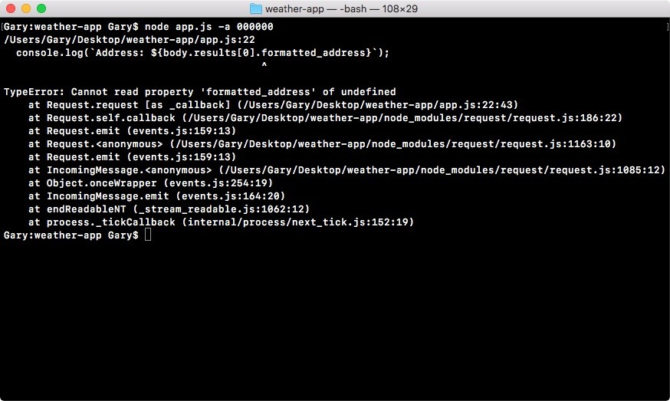

It's trying to fetch properties that don't exist, such as body.results[0].formatted_address is not a real property, and this is a big problem.

Our current callback expects everything went as planned. It doesn't care about the error object, doesn't look at response codes; it just starts printing the data that it wants. This is the happy path, but in real world node apps we have to handle errors as well otherwise the applications will become really useless, and a user can get super frustrated when things don't seem to be working as expected.

In order to do this, we'll add a set of if/else statements inside of the callback. This will let us check certain properties to determine whether or not this call, the one to our URL in the app.js, should be considered a success or a failure. For example, if the response code is a 404, we might want to consider that a failure and we'll want to do something other than trying to print the address, latitude and longitude. If everything went well though, this is a perfectly reasonable thing to do.

There are two types of errors that we'll worry about in this section. That will be:

The machine errors, things like being unable to connect to a network, these are usually will show up in the error object, and

The errors coming from the other server, the Google server, this could be something like an invalid address

In order to get started, let's take a look at what can happen when we pass a bad data to the Google API.

**Checking error in Google API request**

To view what actually comes back in a call like the previous example, where we have an invalid address, we'll head over to the browser and pull up the URL we used in the app.js file:



We will remove the address we used earlier from the browser history, and type in 000000, hit *enter*:

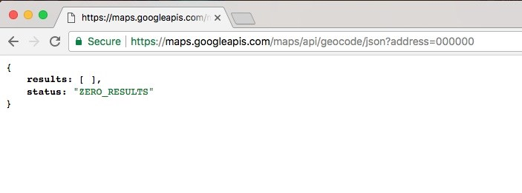

We get our results arrive but those are no results, and we have the status, the status says ZERO_RESULTS, and this is the kind of information that's really important to track down. We can use the status text value to determine whether or not the request was successful. If we pass in a real zip code like 19147, which is Philadelphia, we'll get our results back, and as shown in the following image, the status will get set equal to OK:

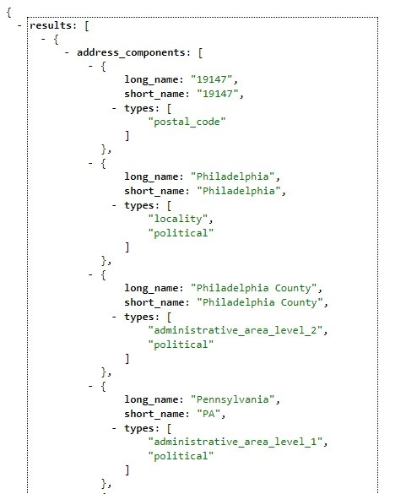

We can use this status to determine that things went well. Between these status property and the error object, which we have inside of our app, we can determine what exactly to do inside of the callback.

**Adding the if statement for**

**callback errors**

The first thing we'll do is add an if statement as shown below, checking if the error object exists:

request({ url: `https://maps.googleapis.com/maps/api/geocode/json?address=${encodedAddress}`, json: true

}, (error, response, body) => { **if (error) {**

**}**

This will run the code inside of our code block if the error object exists, if it doesn't fine, we'll move on into the next else if statement, if there is any.

If there is an error, all we'll do is add a console.log and a message to the screen, something like Unable to connect to Google servers:

if (error) { console.log('Unable to connect Google servers.'); }

This will let the user know that we were unable to connect to the user servers, not that something went wrong with their data, like the address was invalid. This is what be inside of the error object.

Now the next thing that we'll do is add an else if statement, and inside of the condition we'll check the status property. If the status property is ZERO_RESULTS, which it was for the zip code 000000, we want to do something other than trying to print the address. Inside of our conditional in Atom, we can check that using the following statement:

if (error) { console.log('Unable to connect Google servers.'); } else if (body.status === 'ZERO_RESULTS') {

}

If that's the case, we'll print a different message, other than Unable to connect Google

servers, for this one we can use console.log to print Unable to find that address.:

if (error) { console.log('Unable to connect Google servers.'); } else if (body.status === 'ZERO_RESULTS') { console.log('Unable to find that address.'); }

This lets the user know that it wasn't a problem with the connection, we were just unable to find the address they provided, and they should try with something else.

Now we have error handling for those system errors, like being unable to connect to the Google servers, and for errors with the input, in this case we're unable to find a location for that address, and this is fantastic, we have both of our errors handled.

*Now the body.status property that shows up in the else if statement, is not going to be on every API, this is specific to the Google Geocode API. When you explore a new API it's important to try out all sorts of data, good data like a real address and bad data like an invalid zip code, to see exactly what properties you can use to determine whether or not the request was successful, or if it failed.*

In our case, if the status is ZERO_RESULTS, we know the request failed and we can act accordingly. Inside of our app, now we'll add our last else if clause, if things went well.

**Adding if else statement to check body status property**

Now we want to add the else if clause checking if the body.status property equals OK. If it does, we can go ahead and run these three lines inside of the code block:

console.log(`Address: ${body.results[0].formatted_address}`); console.log(`Latitude: ${body.results[0].geometry.location.lat}`); console.log(`Longitude: ${body.results[0].geometry.location.lng}`); });

If it doesn't, these lines shouldn't run because the code block will not execute. Then we'll test things out inside of the Terminal, try to fetch the address of 00000, and make sure that instead of the program crashing we get our error message printing to the screen. Then we go ahead and mess up the URL in the app by removing some of the important characters, and make sure this time we get the

Unable to connect to the Google servers. message. And last we'll see what happens when we enter a valid address, and make sure our three console.log statements still execute.

To get started we'll add that else if statement, and inside of the condition we'll check if body.status is OK:

if (error) { console.log('Unable to connect Google servers.'); } else if (body.status === 'ZERO_RESULTS') { console.log('Unable to find that address.'); } else if (body.status === 'OK') {

}

If it is OK, then we'll simply take the three console.log lines (shown in the previous code block) and move them in the else if condition. If it is OK, we'll run these three console.log statements:

if (error) { console.log('Unable to connect Google servers.'); } else if (body.status === 'ZERO_RESULTS') { console.log('Unable to find that address.');

} else if (body.status === 'OK') {

**console.log(`Address: ${body.results[0].formatted_address}`); console.log(`Latitude: ${body.results[0].geometry.location.lat}`); console.log(`Longitude: ${body.results[0].geometry.location.lng}`);** }

Now we have a request that handles errors really well. If anything goes wrong we have a special message for it, and if things go right we print exactly what the user expects, the address, the latitude, and the longitude. Next we'll test this.

**Testing the body status property**

To test this inside of the Terminal, we'll start by rerunning the command with an address that's invalid:

**node app.js -a 000000**

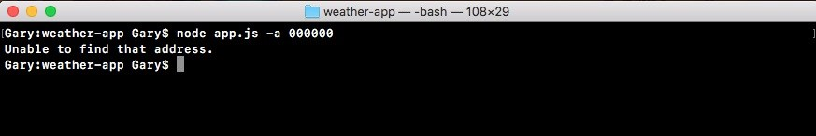

When we run this command, we see that

Unable to find address.

prints to the

screen. Instead of the program crashing, printing a bunch of errors, we simply have a little message printing to the screen. This is because the code we have in second else if statement, that tried to access those properties that didn't exist, no longer runs because our first else if condition gets caught and we simply print the message to the screen.

Now we also want to test that the first message (Unable to connect to the Google servers.) prints when it should. For this, we'll delete some part of the URl in our code, let's say, s and ., and save the file:

request({

**url: `https://mapgoogleapis.com/maps/api/geocode/json?address=${encodedAddress}`,**  json: true

}, (error, response, body) => { if (error) { console.log('Unable to connect Google servers.'); } else if (body.status === 'ZERO_RESULTS') { console.log('Unable to find that address.');

} else if (body.status === 'OK') {

console.log(`Address: ${body.results[0].formatted_address}`); console.log(`Latitude: ${body.results[0].geometry.location.lat}`); console.log(`Longitude: ${body.results[0].geometry.location.lng}`);

}

});

Then we'll rerun the previous command in the Terminal. This time around we can see Unable to connect to Google servers. prints to the screen just like it should:

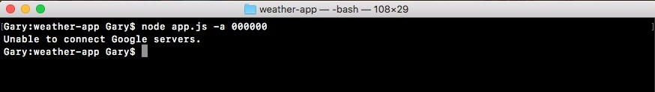

Now we can test it the final thing, by first readjusting the URL to make it correct, and then fetching a valid address from the Terminal. For example, we can use the node app.js, setting address equal to 08822, which is a zip code in New Jersey: **node app.js --address 08822**

When we run this command, we do indeed get our formatted address for Flemington, NJ, with a zip code and the state, and we have our latitude and longitude as shown here:

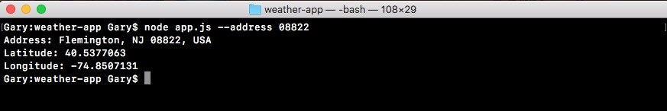

We now have a complete error handling model. When we make a request to Google providing a address that has problems, in this case there's ZERO_RESULTS, the error object will get populated, because it's not technically an error in terms of what request thinks an error is, it's actually in the response object, which is why we have to use body.status in order to check the error.

That is it for this section, we now have error handling in place, we handle system errors, Google server errors, and we have our success case.

**Abstracting callbacks**

In this section, we'll be refactoring app.js, taking a lot of the complex logic related to geocoding and moving it into a separate file. Currently, all of the logic for making the request and determining whether or not the request succeeded, our if else statements, live inside of app.js:

request({ url: `https://maps.googleapis.com/maps/api/geocode/json?address=${encodedAddress}`, json: true

}, (error, response, body) => { if (error) { console.log('Unable to connect Google servers.'); } else if (body.status === 'ZERO_RESULTS') { console.log('Unable to find that address.');

} else if (body.status === 'OK') {

console.log(`Address: ${body.results[0].formatted_address}`); console.log(`Latitude: ${body.results[0].geometry.location.lat}`); console.log(`Longitude: ${body.results[0].geometry.location.lng}`);

}

});

This is not exactly reusable and it really doesn't belong here. What I'd like to do before we add even more logic related to fetching the forecast, that's the topic of the next section, is break this out into its own function. This function will live in a separate file, like we did for the notes application.

In the notes app we had a separate file that had functions for adding, listing, and removing notes from our local adjacent file. We'll be creating a separate function responsible for geocoding a given address. Although the logic will stay the same, there really is no way around it, it will be abstracted out of the app.js file and into its own location.

**Refactoring app.js and code into geocode.js file**

First up, we will need to create a new directory and a new file then we'll add a few more advanced features to the function. But before that, we'll see what the require statement will look like.

**Working on request statement**

We'll load in via a constant variable called geocode the module, and we'll set it equal to require, since we're requiring a local file we'll add that relative path,

./geocode/geocode.js: const geocode = require('./geocode/geocode.js');

That means you need to make a directory called geocode in the weather-app folder, and a file called geocode.js. Since we have a .js extension, we can actually leave it off of our require call.

Now, in the app.js file, next to .argv object, we need to call geocode.geocodeAddress. The geocodeAddress function, that will be the function responsible for all the logic we currently have in app.js. The geocodeAddress function will take the address, argv.address: geocode.geocodeAddress(argv.address);

It will be responsible for doing everything, encoding the URL, making the request, and handling all of the error cases. This means, in that new file we need to export the geocodeAddress function, just like we exported functions from the notes application file. Next, we have all of the logic here:

var encodedAddress = encodedURIComponent(argv.address);

request({ url: `https://maps.googleapis.com/maps/api/geocode/json?address=${encodedAddress}`, json: true

}, (error, response, body) => { if (error) { console.log('Unable to connect Google servers.'); } else if (body.status === 'ZERO_RESULTS') { console.log('Unable to find that address.');

} else if (body.status === 'OK') {

console.log(`Address: ${body.results[0].formatted_address}`); console.log(`Latitude: ${body.results[0].geometry.location.lat}`); console.log(`Longitude: ${body.results[0].geometry.location.lng}`); }

});

This logic needs to get moved inside of the geocodeAddress function. Now we can copy and paste the preceding shown code directly, there really is no way around some of the more complex logic, but we will need to make a few changes. We'll need to load requests into that new file, since we use it and it isn't going to be required in that file by default. Then we can go ahead and clean up the request require call in the code, since we won't be using it in this file.

Next up, the argv object is not going to exist, we'll get that passed in via the first argument, just like the argv.address in the geocode.Address statement. This means we'll need to swap this out for whatever we call that first argument for example, address. Once this is done, the program should work exactly as it works without any changes in app.js, there should be no change in functionality.

**Creating geocode file**

To get started, let's make a brand new directory in the weather-app folder, that's the first thing we need to do. The directory is called geocode, which aligns with the require statement we have in the geocode variable. In geocode folder, we'll make our file geocode.js:

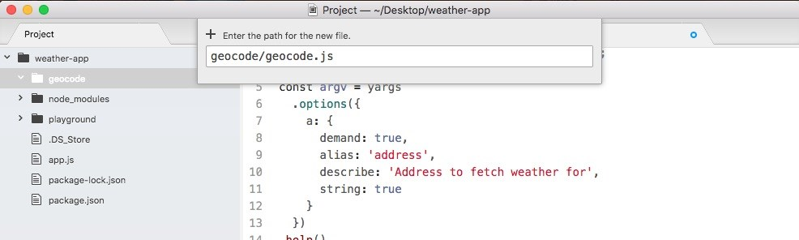

Now inside of geocode.js, we can get started by loading in request, let's make a constant called request, and we'll set it equal to require('request'): const request = require('request');

Now we can go ahead and define the function responsible for geocoding, this one will be called geocodeAddress. We'll make a variable called geocodeAddress, setting it equal to an arrow function, and this arrow function will get an address argument past in:

var geocodeAddress = (address) => {

};

This is the plain text unencoded address. Now before we copy the code from app.js into this function body, we want to export our geocodeAddress function using module.exports, which we know as an object. Anything we put on module.exports object will be available to any files that require this file. In our case, we want to make a geocodeAddress property available, setting it equal to the geocodeAddress function that we defined in the preceding statement:

var geocodeAddress = (address) => {

}; module.exports.geocodeAddress = geocodeAddress;

Now it's time to actually copy all of the code from app.js in to geocode.js. We'll cut the request function code, move in to geocode.js, and paste it inside of the body of our function:

var geocodeAddress = (address) => {

var encodedAddress = encodedURIComponent(argv.address);

request({ url: `https://maps.googleapis.com/maps/api/geocode/json?address=${encodedAddress}`, json: true

}, (error, response, body) => { if (error) { console.log('Unable to connect Google servers.'); } else if (body.status === 'ZERO_RESULTS') { console.log('Unable to find that address.');

} else if (body.status === 'OK') {

console.log(`Address: ${body.results[0].formatted_address}`); console.log(`Latitude: ${body.results[0].geometry.location.lat}`); console.log(`Longitude: ${body.results[0].geometry.location.lng}`);

}

}); }; module.exports.geocodeAddress = geocodeAddress;

The only thing we need to change inside of this code, is how we get the plaintext address. We no longer have that argv object, instead we get address passed in as an argument. The final code will look like the following code block:

const request = require('request');

var geocodeAddress = (address) => {

var encodedAddress = encodedURIComponent(argv.address);

request({ url: `https://maps.googleapis.com/maps/api/geocode/json?address=${encodedAddress}`, json: true

}, (error, response, body) => { if (error) { console.log('Unable to connect Google servers.'); } else if (body.status === 'ZERO_RESULTS') { console.log('Unable to find that address.');

} else if (body.status === 'OK') {

console.log(`Address: ${body.results[0].formatted_address}`); console.log(`Latitude: ${body.results[0].geometry.location.lat}`); console.log(`Longitude: ${body.results[0].geometry.location.lng}`);

}

}); }; module.exports.geocodeAddress = geocodeAddress;

With this in place, we're now done with the geocode file. It contains all of the complex logic for making and finishing the request. Over at app.js, we can clean things up by removing some extra spaces, and removing the request module which is no longer used in this file. The final app.js file will look like the following code block:

const yargs = require('yargs'); const geocode = require('./geocode/geocode');

const argv = yargs .options({ a: { demand: true, alias: 'address', describe: 'Address to fetch weather for', string: true

}

})

.help()

.alias('help', 'h')

.argv; geocode.geocodeAddress(argv.address);

Now at this point the functionality should be exactly the same. Inside of the Terminal, I'll go ahead and run a few to confirm the changes worked. We'll use the a flag to search for a zip code that does exist, something like 19147, and as shown, we can see the address, the latitude, and the longitude:

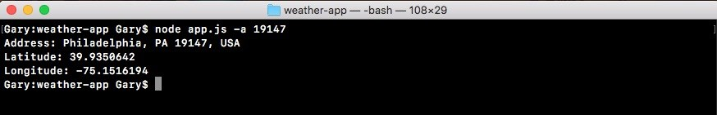

Now we'll swap out that zip code to one that does not exist, like 000000, when we run this through the geocoder, you can see Unable to find address prints to screen:



It means all of the logic inside of geocode.js is still working. Now the next step in the process is the process of adding a callback function to geocodeAddress.

**Adding callback function to geocodeAddress**

The goal of refactoring the code and app.js was not to get rid of the callback, the goal was to abstract all the complex logic related to encoding the data, making that request, and checking for errors. app.js should not care about any of that, it doesn't even need to know that an HTTP request was ever made. All the app.js should care about is passing an address to the function, and doing something with the result. The result being either an error message or the data, the formatted address, the latitude, and the longitude.

**Setting up the function in geocodeAddress function in**

**app.js**

Before we go ahead and make any changes in geocode.js, we want to take a look at how we'll structure things inside of app.js. We'll pass an arrow function to geocodeAddress, and this will get called after the request comes back:

geocode.geocodeAddress(argv.address, () => {

});

In the parentheses, we'll expect two arguments, errorMessage, which will be a string, and results, which will contain the address, the latitude, and the longitude:

geocode.geocodeAddress(argv.address, (errorMessage, results) => {

});

Out of these two only one will be available at a time. If we have an error message we'll not have results, and if we have results we'll not have an error message. This will make the logic in the arrow function, of determining whether or not the call succeeded, much simpler. We'll be able to use an if statement, if (errorMessage), and if there is an error message, we can simply print it to the screen using console.log statement:

geocode.geocodeAddress(argv.address, (errorMessage, results) => { if (errorMessage) { console.log(errorMessage);

}

});

There's no need to dig into any sort of object and figure out exactly what's going on, all of that logic is abstracted in geocode.js. Now if there is no error message inside of the else clause, we can go ahead and print the results. We'll use that pretty print method we talked about in the previous chapter, we'll add the console.log(JSON.stringify) statement, and we'll pretty print the results object which will be an object containing an address property, a latitude property, and a longitude property.

Then, we'll pass the undefined argument as our second argument. This skips over the filtering function which we don't need, and then we can specify the spacing, which will format this in a really nice way, we'll use two spaces as shown here:

geocode.geocodeAddress(argv.address, (errorMessage, results) => { if (errorMessage) { console.log(errorMessage);

} else {

console.log(JSON.stringify(results, undefined, 2));

}

});

Now that we have our function set up inside of geocodeAddress function in app.js, and we have a good idea about how it will look, we can go ahead and implement it inside of geocode.js.

**Implementing the callback function in geocode.js file**

In our arguments definition, instead of just expecting an address argument we'll also expect a callback argument, and we can call this callback argument whenever we like. We'll call it in three places. We'll call it once inside of the if

(error) block, instead of calling console.log we'll simply call the callback with the

Unable to connect to Google servers. string. This string will be the error message we defined in geocodeAddress function in app.js.

In order to do this, all we need to do is change our console.log call to a callback call. We'll pass it as the first argument our error message. We can take the string exactly as it appeared in console.log, and move it into the arguments for callback. Then I can remove the console.log call and save the file. The resultant code will look like following:

request({ url: `https://maps.googleapis.com/maps/api/geocode/json?address=${encodedAddress}`, json: true

}, (error, response, body) => { if (error) { callback('Unable to connect to Google servers.'); }

Now we can do the exact same thing in the next else if block for our other console.log statement, when there is zero results, we'll replace console.log with callback:

if (error) { callback('Unable to connect Google servers.');

} else if (body.status === 'ZERO_RESULTS') { callback('Unable to find that address.'); }

Now the last else if block will be a little trickier. It's a little trickier because we don't exactly have our object. We also need to create an undefined variable for the first argument, since an error message will not be provided when things go well. All we have to do to create that undefined error message is call callback, passing an undefined variable as the first argument. Then we can go ahead and specify our object as the second argument, and this object, this will be exactly what's in the geocodeAddress function, results:

} else if (body.status === 'OK') { callback(undefined, {

})

console.log(`Address: ${body.results[0].formatted_address}`); console.log(`Latitude: ${body.results[0].geometry.location.lat}`); console.log(`Longitude: ${body.results[0].geometry.location.lng}`); }

Now as I mentioned the results have three properties: the first one will be formatted address, so let's go ahead and knock that out first. We'll set address equal to body.results, just like we have in the Address variable of console.log statement:

} else if (body.status === 'OK') { callback(undefined, { address: body.results[0].formatted_address

})

console.log(`Address: ${body.results[0].formatted_address}`); console.log(`Latitude: ${body.results[0].geometry.location.lat}`); console.log(`Longitude: ${body.results[0].geometry.location.lng}`); }

Here we're making things even easier, instead of having complex properties that are nested deep inside of an object inside of app.js, we'll be able to access a simple address property, and we'll do the same thing for Latitude and Longitude of console.log statements.

Next, we'll grab the code that let us fetch the latitude, and I'll add my second property, latitude, setting it equal to the code we grab from the console.log statement. Then we can go ahead and add the last property, which will be longitude, setting that equal to the latitude code, replacing lat with lng. Now that we have this in place we can add a semicolon at the end, and remove the console.log statements since they're no longer necessary, and with this we are done:

if (error) { callback('Unable to connect Google servers.');

} else if (body.status === 'ZERO_RESULTS') { callback('Unable to find that address.'); } else if (body.status === 'OK') { callback(undefined, { address: body.results[0].formatted_address, latitude: body.results[0].geometry.location.lat, longitude: body.results[0].geometry.location.lng });

}

We can now rerun the file, and when we do we'll pass an address to geocodeAddress, this will go off and make the request, and when the request comes back, we'll be able to handle that response in a really simple way.

**Testing the callback function in geocode.js file**

Inside of the Terminal, we'll go back to run two node app.js commands; the command where we used the zip code of 19147, everything works as expected and a bad zip code 000000, to show the error message.

As shown in the following code output, we can see our results object with an address property, a latitude property, and a longitude property:

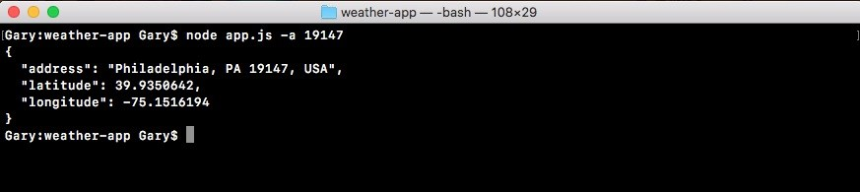

In case of a bad zip code, we just want to make sure the error message still shows up, and it does, Unable to find that address. prints to the screen, as shown here:



This is happening because of the if statement in the geocodeAddress function in app.js.

After abstracting all of that logic to the geocode file, the app.js file is now a lot simpler and a lot easier to maintain. We can also call geocodeAddress in multiple locations. If we want to reuse the code we don't have to copy and paste the code, which would not follow the **DRY** principle, which stands for **Don't Repeat Yourself**, instead we can do the DRY thing and simply call geocodeAddress like we have in the app.js file. With this in place we are now done fetching the geocode data.

**Wiring up weather search**

In this section, you'll make your very first request to the weather API, and we'll do this in a static way at first, meaning that it will not use the actual latitude and longitude for the address we passed in, we'll simply have a static URL. We'll make the request and we'll explore what data we get back in the body.

**Exploring working of API in the browser**

Now before we can add anything to Atom, we want to go ahead and explore this API so we can see how it works in the browser. This will give us a better idea about what weather data we get back, when we pass a latitude and longitude to the API. To do this we'll head over to the browser, and we'll visit a couple of URLs.

First up let's go to [forecast.io](http://forecast.io/). It is a regular weather website, you type in your location and you get all the weather information you'd expect:

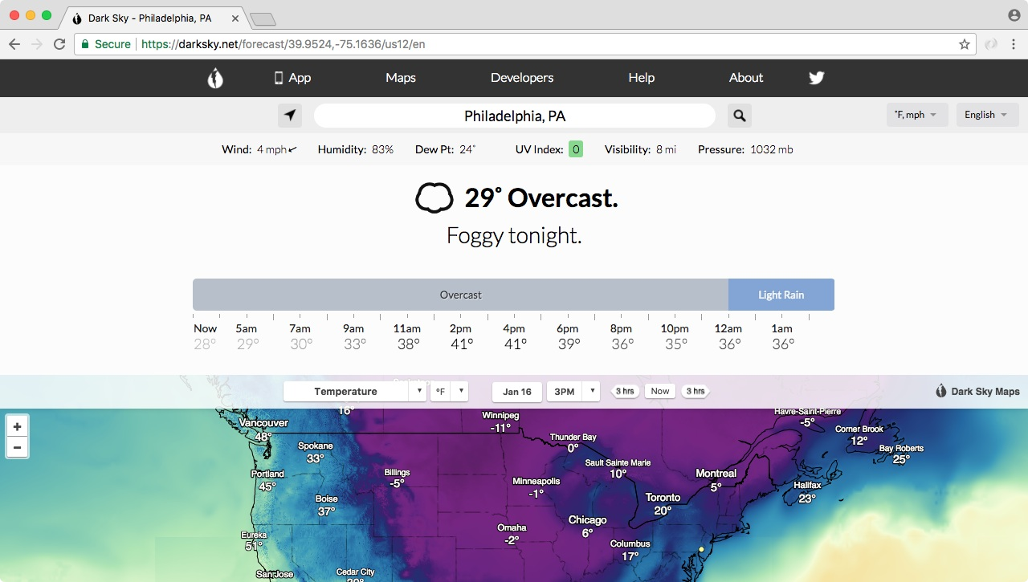

As shown in the preceding image, there's warnings, there's radar, there's the current weather, and we also have the weekly forecast in the website as shown in the following image:

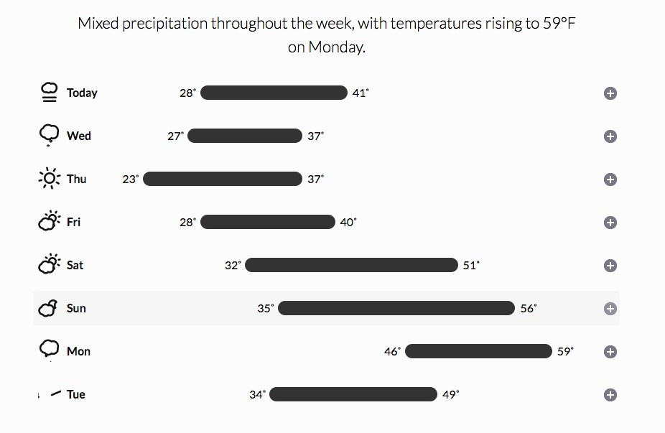

This is similar to [weather.com](http://weather.com/), but the one cool thing about [forecast.io](http://forecast.io/) is that the API that powers this website, it's actually available to you as a developer. You can make a request to our URL, and you can fetch the exact same weather information.

That is exactly what we'll do when we can explore the API by going to the website [developer.forecast.io](http://developer.forecast.io/). Here we can sign up for a free developer account, in order to get started making those weather requests:

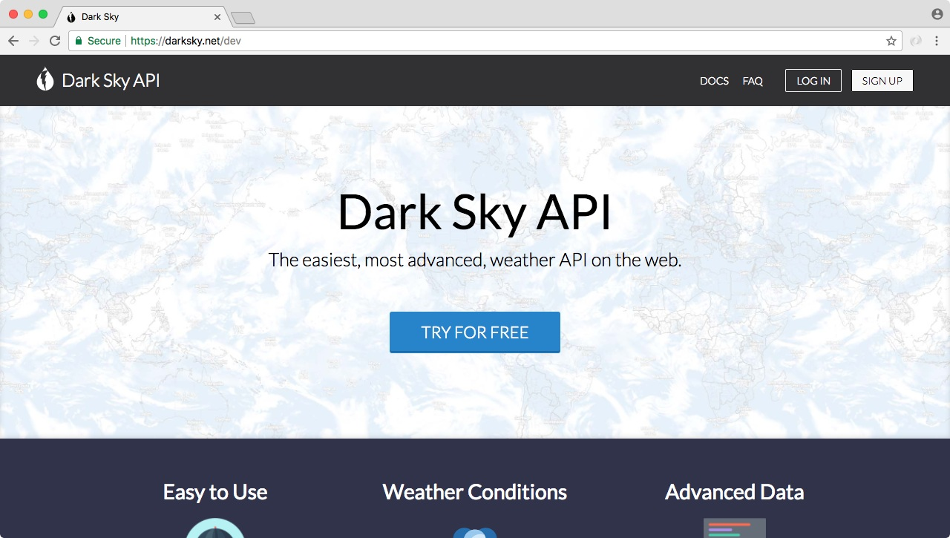

The Dark Sky Forecast API gives you 1,000 free requests a day, and I do not see us going over that limit. After the 1,000 requests, each costs a one thousandth of a penny, so you get a thousand requests for every penny you spend. We'll never go over that limit so don't even worry about it. There is no credit card required to get started, you'll simply get cut off after you make a thousand requests.

To get started you'll need to register for a free account, it's really simple, we just need an email and a password. Once we've created an account and we can see the dashboard as shown here:

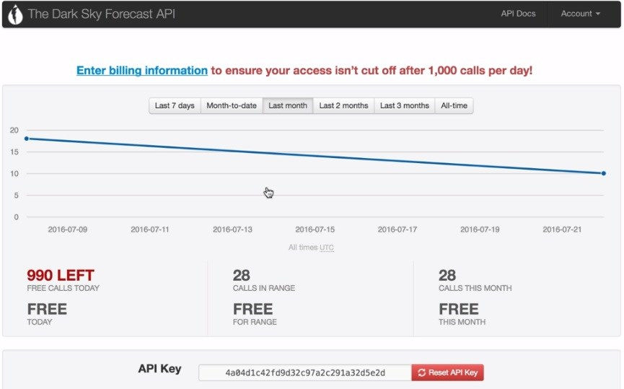

The only piece of information we need from this page is our API key. The API [key is like a password, it will be part of the URL we request and it will help forec ast.io keep track of how many requests we make a day. Now I'll take this API](http://forecast.io/) key and paste it in the app.js, so we have it accessible later when we need it.

The next thing we'll do is explore the documentation, the actual URL structure we need to provide in order to fetch the weather for a given latitude and longitude. We can get that by clicking the API Docs link button, which is present in the top-right side of The Dark Sky Forecast API page. This'll lead us to following page:

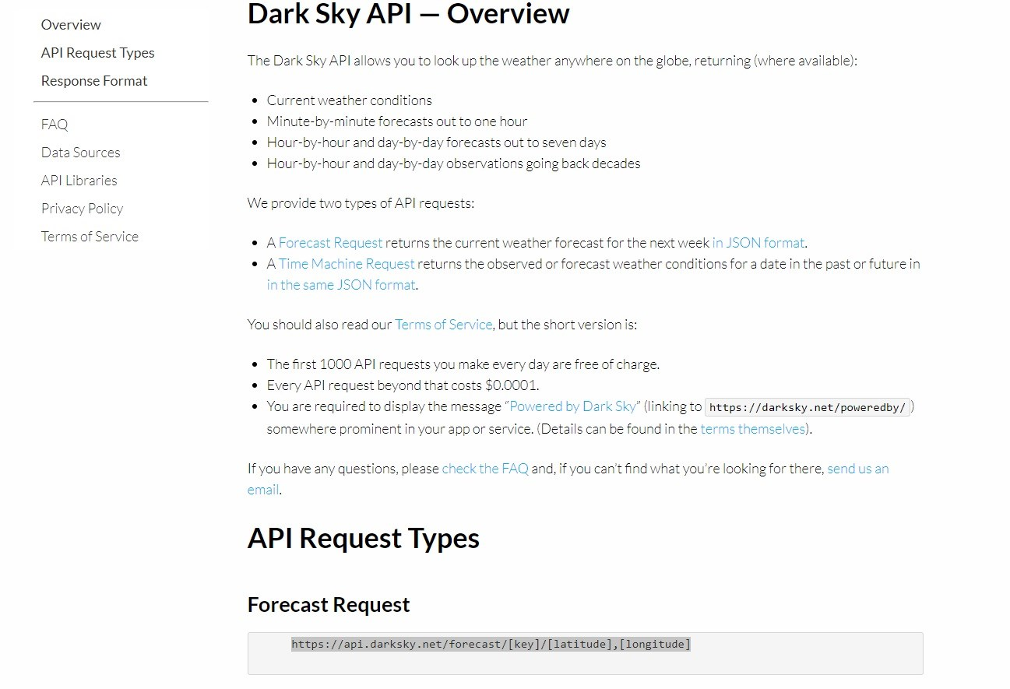

In the API Docs link, we have a Forecast Request URL. As shown in the preceding image, this URL is exactly what we need to make a request to in order to fetch the data.

**Exploring the actual URL for code**

Before we add this URL into our app and use the request library, we need to find the actual URL which we can use to make the request. For this, we'll copy it and paste it into a new tab:



Now, we do need to swap out some of the URL information. For example, we have our API key that needs to get replaced, we also have latitude and longitude. Both of those need to get replaced with the real data. Let's get started with that API key first since we already copy and pasted it inside of app.js. We'll copy the API key, and replace the letters [key] with the actual value:



Next up, we can grab a set of longitude and latitude coordinates. For this, go inside the Terminal and run our app, node app.js, and for the address we can use any zip let's say, 19146 to fetch the latitude and longitude coordinates.

Next up, we'll copy these and place into the URL where they belong. The latitude goes between the forward slash and the comma, and the longitude will go after the comma, as shown here:



Once we have a real URL with all of those three pieces of info swapped out for actual info, we can make the request, and what we'll get back is the forecast information:

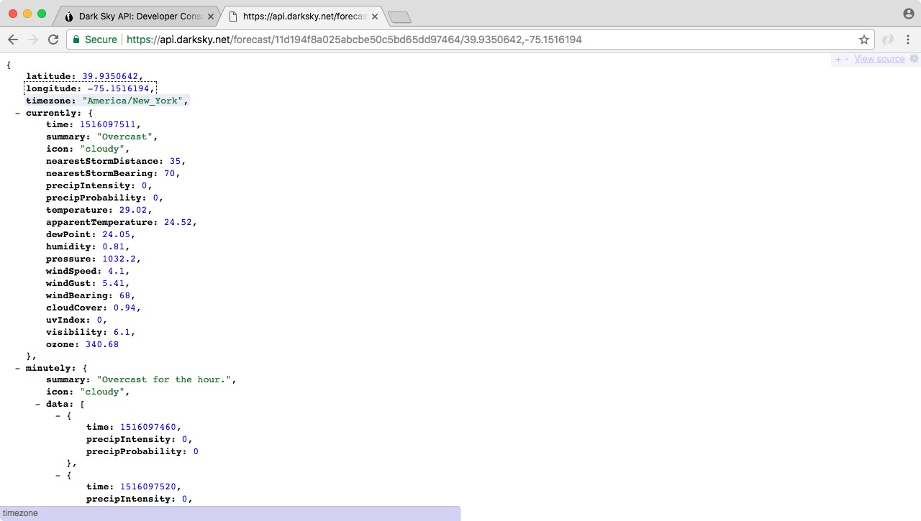

*Remember, this way the information is showing in the preceding image is due to JSONView, I highly recommend installing it.*

Now the data we get back, it is overwhelming. We have a forecast by the minute, we have forecasts by the hour, by the week, by the day, all sorts of information, it's really useful but it's also super overwhelming. In this chapter, we'll be using the first object that is currently. This stores all of the current weather information, things like the current summary which is clear, the temperature, the precipitation probability, the humidity, a lot of really useful information is sitting in it.

In our case, what we really care about is the temperature. The current temperature in Philadelphia is shown 84.95 degrees. This is the kind of information we want to use inside of our application, when someone searches for the weather in a given location.

**Making a request for the weather app using the static URL**

Now in order to play around with the weather API, we'll take the exact same URL we have defined in the previous section, and we'll make a request in app.js. First, we want to do a little setup work.

Inside of app.js, we'll comment out everything we have so far, and next to our API key we'll make a call to request, requesting this exact URL, just like we did for the geocode API in the previous section/chapter, before we made it dynamic.

Then we'll print out the body.currently.temperature property to the screen, so when we run the app we'll see the current temperature for whatever latitude and longitude we used. In our case it's a static latitude and longitude representing Philadelphia.

In order to get started we'll load in request. Now we had it in the app.js file before and then we removed it in the previous section, but we'll add it back once again. We'll add it next to the commented out code, by creating a constant called request, and loading it in, const request equals to require('request'): const request = require('request');

Now we can go ahead and make the actual request, just like we did for the geocode API by calling request, it's a function just like this:

const request = require('request'); request();

We have to pass in our two arguments, the options object is the first one, and the second one is the arrow function:

request({}, () => {

});

This is our callback function that gets fired once the HTTP request finishes. Before we fill out the actual function, we want to set up our options. There're two options, URL and JSON. We'll set url equal to the static string, the exact URL we have in the browser:

request({ url: 'https://api.forecast.io/forecast/4a04d1c42fd9d32c97a2c291a32d5e2d/39.9396284,-75

}, () => {

Then in the next line after comma, we can set json equal to true, telling the request library to go ahead and parse that body as JSON, which it is:

request({ url: 'https://api.forecast.io/forecast/4a04d1c42fd9d32c97a2c291a32d5e2d/39.9396284,-75 json: true }, () => {

From here, we can go ahead and add our callback arguments; error, response, and body. These are the exact same three arguments we have in the if block of geocode.js file for the geocoding request:

request({ url: 'https://api.forecast.io/forecast/4a04d1c42fd9d32c97a2c291a32d5e2d/39.9396284,-75 json: true

}, (error, response, body) => {

});

Now that we have this in place, the last thing we need to do is print the current temperature, which is available on the body using console.log statement. We'll use console.log to print body.currently.temperature, as shown here:

request({ url: 'https://api.forecast.io/forecast/4a04d1c42fd9d32c97a2c291a32d5e2d/39.9396284,-75 json: true

}, (error, response, body) => { **console.log(body.currently.temperature);** });

Now that we have the temperature printing, we need to test it by running it from the Terminal. In the Terminal, we'll rerun the previous command. The address is not actually being used here since we commented out that code, and what we get is 28.65, as shown in this code output:

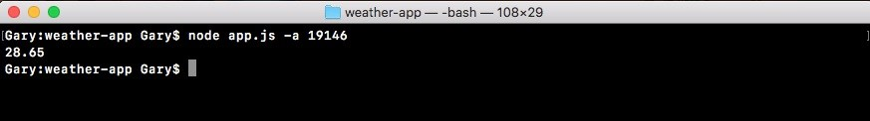

With this we have our weather API call working inside of the application.

**Error handling in the the callback function**

Now we do want to add a little error handling inside of our callback function. We'll handle errors on the error object, and we'll also handle errors that come back from the [forecast.io](http://forecast.io/) servers. First up, just like we did for the geocoding API, we'll check if error exists. If it does, that means that we were unable to connect to the servers, so we can print a message that relays that message to the user, console.log something like Unable to connect to forecast.io server.:

request({ url: 'https://api.forecast.io/forecast/4a04d1c42fd9d32c97a2c291a32d5e2d/39.9396284,-75 json: true

}, (error, response, body) => { if (error){ console.log('Unable to connect to Forecast.io server.');

}

console.log(body.currently.temperature); });

Now that we've handled general errors, we can move on to a specific error that the [forecast.io](http://forecast.io/) API throws. This happens when the format of the URL, the latitude and longitude, is not correct.

For example, if we delete some numbers including the comma in the URL, and hit *enter* we'll get a 400 Bad Request:

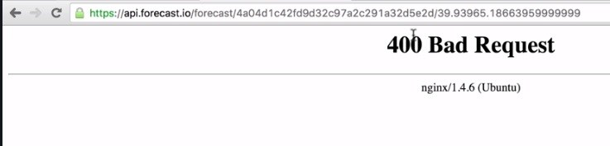

This is the actual HTTP status code. If you remember from the geolocation API we had a body.status property that was either OK or ZERO_RESULTS. This is similar to that property, only this uses the HTTP mechanisms instead of some sort of custom solution that Google used. In our case, we'll want to check if the status code is 400. Now if we have a bad API key, I'll add a couple e's in the URL, we'll also get a 400 Bad Request:

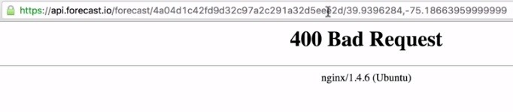

So both of these errors can be handled using the same code.

Inside of Atom, we can handle this by checking the status code property. After our if statement closing curly brace, we'll add else if block, else if (response.statusCode), this is the property we looked at when we looked at the response argument in detail. response.statusCode will be equal to 400 if something went wrong, and that's exactly what we'll check for here:

if (error){ console.log('Unable to connect to Forecast.io server.'); } else if (response.statusCode === 400) {

}

If the status code is 400 we'll print a message, console.log('Unable to fetch weather'):

if (error){ console.log('Unable to connect to Forecast.io server.');

} else if (response.statusCode === 400) { console.log('Unable to fetch weather.'); }

Now we've handled those two errors, and we can move on to the success case.

For this we'll add another else if block with response.statusCode equals 200. The status code will equal 200 if everything went well, in that case we'll print the current temperature to the screen.

I'll cut the console.log(body.currently.temperature) line out and paste it inside of the else if code block:

if (error){ console.log('Unable to connect to Forecast.io server.');

} else if (response.statusCode === 400) { console.log('Unable to fetch weather.'); } else if (response.statusCode === 200) { console.log(body.currently.temparature); }

});

**Another way of error handling**

There's is another way to represent our entire if block code. The following is an updated code snippet, and we can actually replace everything we have in the current callback function with this code:

if (!error && response.statusCode === 200) { console.log(body.currently.temperature);

} else {

console.log('Unable to fetch weather.'); }

This condition checks if there is no error and the response status code is a 200, if that's the case what do we do? We simply print the temperature like we were doing last time, that was in the else if clause at the very bottom. Now we have an else case in the updated code snippet, so if there is an error or the status code is not a 200, we'll go ahead and print this message to the screen. This will handle things like the server not having a network connection, or 404s from an invalid or broken URL. All right, use this code instead and everything should be working as expected with the latest version of the weather API.

**Testing the error handling in callback**

Now we have some error handling in place and we can go ahead and test that our app still works. From the Terminal we'll rerun the previous command, and we still get a temperature 28.71:

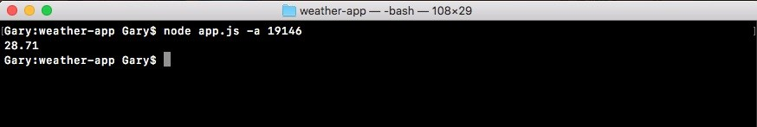

Back inside of Atom, we'll trash some of the data by removing the comma, saving the file:

request({ **url: 'https://api.forecast.io/forecast/4a04d1c42fd9d32c97a2c291a32d5e2d/39.9396284-75.**

json: true

}, (error, response, body) => { if (error){ console.log('Unable to connect to Forecast.io server.');

} else if (response.statusCode === 400) { console.log('Unable to fetch weather.'); } else if (response.statusCode === 200) { console.log(body.currently.temparature);

}

});

When we rerun it from the Terminal, this time, we would expect Unable to fetch weather. to print to the screen, and when I rerun the app that is exactly what we get, as shown here:



Now, let's add the comma back in and test our last part of the code. To test the if error, we can test that by removing something like the dot from forecast.io:

request({ **url: 'https://api.forecastio/forecast/4a04d1c42fd9d32c97a2c291a32d5e2d/39.9396284,-75.**

json: true

}, (error, response, body) => {

We can rerun the app, and we see Unable to connect to Forecast.io server.:



All of our error handling works great, and if there is no errors the proper temperature prints to the screen, which is fantastic.

**Chaining callbacks together**

In this section, we'll take the code that we created in the last section, and break it out into its own file. Similar to what we did with the Geocoding API request where we called geocodeAddress instead of actually having the request call in app.js. That means we'll make a new folder, a new file, and we'll create a function in there that gets exported.

After that we'll go ahead and learn how to chain callbacks together. So when we get that address from the Terminal we can convert that into coordinates. And we can take those coordinates and convert them into temperature information, or whatever weather data we want to pull off of the return result from the Forecast API.

**Refactoring our request call in weather.js file**

Now before we can dive into the refactoring, we'll create a brand new file, and we'll worry about getting the code we created in the previous section into that function. Then we'll go for creating that callback.

**Defining the new function getWeather in weather file**

First, let's make the directory. The directory will be called weather. And in the weather directory we'll make a new file called weather.js.

Now in this file we can take all of our code from app.js, and paste it in weather.js:

const request = require('request');

request({ url: 'https://api.forecast.io/forecast/4a04d1c42fd9d32c97a2c291a32d5e2d/39.9396284,-7 json: true

}, (error, response, body) => { if (error) { console.log('Unable to connect to Forecast.io server.');

} else if (response.statusCode === 400) { console.log('Unable to fetch weather.'); } else if (response.statusCode === 200) { console.log(body.currently.temperature);

}

});

The only thing we need to do in order to take this code and convert it to create that function, which will get exported. And then we can move our call to the request inside of it. We'll make a brand new function called getWeather next to the request variable:

const request = require('request'); var getWeather = () => {

};

getWeather will take some arguments, but that'll be added later. For now we'll leave the arguments list empty. Next, we'll take our call to request and move it inside the getWeather function:

const request = require('request'); var getWeather = () => { request({ url: 'https://api.forecast.io/forecast/4a04d1c42fd9d32c97a2c291a32d5e2d/39.9396284, json: true

}, (error, response, body) => { if (error) { console.log('Unable to connect to Forecast.io server.');

} else if (response.statusCode === 400) {

console.log('Unable to fetch weather.'); } else if (response.statusCode === 200) { console.log(body.currently.temperature);

}

});

};

Then, we can go ahead and export this getWeather function. We'll add module.exports.getWeather and set it equal to the getWeather function that we defined up:

module.exports.getWeather = getWeather;

**Providing weather directory in app.js**

Now that we have this in place, we can go ahead and move into app.js to add some code. The first thing we need do is remove the API key. We no longer need that. And we'll highlight all of the commented code and uncomment it using the command /.

Now we'll import the weather.js file. We'll create a const variable called weather, and setting it equal to the require, return result:

const yargs = require('yargs');

const geocode = require('./geocode/geocode'); const weather = require('');

In this case we're requiring our brand new file we just created. We'll provide a relative path ./ because we're loading in a file that we wrote. Then we'll provide the directory named weather followed by the file named weather.js. And we can leave off that js extension, as we already know: const weather = require('./weather/weather');

Now that we have the Weather API loaded in, we can go ahead and call it. We'll comment out our call to geocodeAddress and, we'll run weather.getWeather():

// geocode.geocodeAddress(argv.address, (errorMessage, results) => {

// if (errorMessage) {

// console.log(errorMessage);

// } else {

// console.log(JSON.stringify(results, undefined, 2));

// } //}); weather.getWeather();

Now as I mentioned before, there will be arguments later in the section. For now we'll leave them empty. And we can run our file from the Terminal. This means we should see the weather printing for the coordinates, we hard-coded in the previous section. So, we'll run node app.js. We'll need to provide an address since we haven't commented out the yargs code. So we'll add a dummy address. I'll use a zip code in New Jersey:

**node app.js -a 08822**

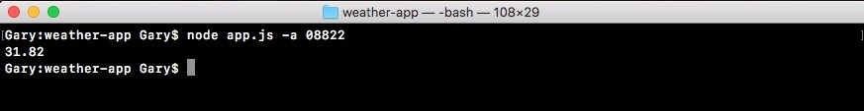

Now, the

geolocation

code is never running, because that is commented out. But

we are running the weather code that got moved to the new file. And we are indeed seeing a temperature 31.82 degrees, which means that the code is properly getting executed in the new file.

**Passing the arguments in the getWeather function**

Now we'll need to pass in some arguments, including a callback function and inside getWeather variable in weather file. We'll need to use those arguments instead of a static lat/lng pair. And we'll also need to call the callback instead of using console.log. The first thing we'll do before we actually change the weather.js code is change the app.js code. There are three arguments to be added. These are lat, lng and callback.

First up we'll want to pass in the latitude. We'll take the static data, like the latitude part from the URL in weather.js, copy it, and paste it right inside of the arguments list in app.js as first argument. The next one will be the longitude. We'll grab that from the URL, copy it, and paste it inside of app.js as the second argument:

// lat, lng, callback weather.getWeather(39.9396284, -75.18663959999999);

Then we can go ahead and provide the third one, which will be the callback function. This function will get fired once the weather data comes back from the API. I'll use an arrow function that will get those two arguments we discussed earlier in the previous section: errorMessage and weatherResults:

weather.getWeather(39.9396284, -75.18663959999999, (errorMessage, weatherResults) => {

});

The weatherResults object containing any sort of temperature information we want. In this case it could be the temperature and the actual temperature. Now, we have used weatherResults in place of results, and this is because, we want to differentiate weatherResults from the results variable in geocodeAddress.

**Printing errorMessage in the getWeather function**

Inside of the getWeather function in app.js, we now need to use if-else statements in order to print the appropriate thing to the screen, depending on whether or not the error message exists. If there is errorMessage we do want to go ahead and print it using console.log. In this case we'll pass in the errorMessage variable:

weather.getWeather(39.9396284, -75.18663959999999, (errorMessage, weatherResults) => { if (errorMessage) { console.log(errorMessage);

}

});

Now if there is no error message we'll use the weatherResults object. We'll be printing a nice formatted message later. For now we can simply print the weatherResults object using the pretty printing technique we talked about in the previous chapter, where we call JSON.stringify inside of console.log:

weather.getWeather(39.9396284, -75.18663959999999, (errorMessage, weatherResults) => { if (errorMessage) { console.log(errorMessage);

} else {

console.log(JSON.stringify());

}

});

Inside the JSON.stringify parentheses, we'll provide those three arguments, the actual object; weatherResults, undefined for our filtering function, and a number for our indentation. In this case we'll go with 2 once again:

weather.getWeather(39.9396284, -75.18663959999999, (errorMessage, weatherResults) => { if (errorMessage) { console.log(errorMessage);

} else {

console.log(JSON.stringify(weatherResults, undefined, 2)); }

});

And now that we have our getWeather call getting called with all three arguments, we can go ahead and actually implement this call inside of weather.js.

**Implementing getWeather callback inside weather.js file**

To get started we'll make the URL in the weather.js file dynamic, which means we need to replace the url strings with template strings. Once we have template strings in place, we can inject the arguments, latitude and longitude, right into the URL.

**Adding dynamic latitude and longitude**

Let's go ahead and define all the arguments that are getting passed in. We add lat, lng, and our callback: var getWeather = (lat, lng, callback) => {

First off let's inject that latitude. We'll take the static latitude, remove it, and between the forward slash and the comma we'll inject it using dollar with our curly braces. This lets us inject a value into our template string; in this case lat. And we can do the exact same thing right after the comma with the longitude. We'll remove the static longitude, use the dollar sign with our curly braces to inject the variable into the string:

var getWeather = (lat, lng, callback) => { request({ url: `https://api.forecast.io/forecast/4a04d1c42fd9d32c97a2c291a32d5e2d/${lat},${ln

Now that the URL is dynamic, the last thing we need to do inside of getWeather is change our console.log calls to callback calls.

**Changing console.log calls into callback calls**

To change our console.log into callback calls, for the first two console.log calls we can replace console.log with callback. And this will line up with the arguments that we specified in app.js, where the first one is the errorMessage and the second one is the weatherResults. In this case we'll pass the errorMessage back and the second argument is undefined, which it should be. We can do the same thing for Unable to fetch weather:

if (error) { callback('Unable to connect to Forecast.io server.');

} else if (response.statusCode === 400) { callback('Unable to fetch weather.'); }

Now the third console.log call will be a little more complex. We'll have to actually create an object instead of just passing the temperature back. We'll call the callback with the first argument being undefined, because in this case there is no errorMessage. Instead we'll provide that weatherResults object:

if (error) { callback('Unable to connect to Forecast.io server.');

} else if (response.statusCode === 400) { callback('Unable to fetch weather.'); } else if (response.statusCode === 200) { callback(undefined, {

})

console.log(body.currently.temperature); }

Inside the parentheses, we can define all the temperature properties we like. In this case we'll define temperature, setting it equal to body.currently, which stores all of the currently weather data, .temperature:

else if (response.statusCode === 200) { callback(undefined, { temperature: body.currently.temperature

})

console.log(body.currently.temperature); }

Now that we have the temperature variable we can go ahead and provide that second property to the object, which is actual temperature. Actual temperature will account for things like humidity, wind speed, and other weather conditions. The actual temperature data is available under a property on currently called apparentTemperature. We'll provide that. And as the value we'll use the same thing. This gets us to the currently object, just like we do for temperature. This will be

body.currently.apparentTemperature:

else if (response.statusCode === 200) { callback(undefined, { temperature: body.currently.temperature, apparentTemperature: body.currently.apparentTemperature

})

console.log(body.currently.temperature); }

Now we have our two properties, so we can go ahead and remove that console.log statement. Add a semicolon. The final code will look like:

const request = require('request');

var getWeather = (lat, lng, callback) => { request({ url: `https://api.forecast.io/forecast/4a04d1c42fd9d32c97a2c291a32d5e2d/${lat},${ln json: true

}, (error, response, body) => { if (error) { callback('Unable to connect to Forecast.io server.');

} else if (response.statusCode === 400) { callback('Unable to fetch weather.'); } else if (response.statusCode === 200) { callback(undefined, { temperature: body.currently.temperature, apparentTemperature: body.currently.apparentTemperature

});

}

}); }; module.exports.getWeather = getWeather;

Now we can go ahead and run the app. We have our getWeather function wired up both inside of the weather.js file and inside of app.js. Now once again we are still using static coordinates, but this will be the last time we run the file with that static data. From the Terminal we'll rerun the application:

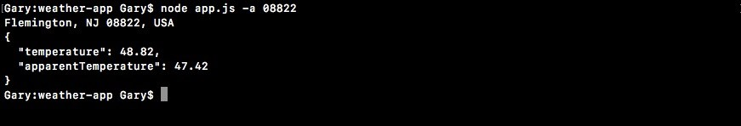

And as shown we get our temperature object printing to the screen. We have our temperature property 48.82 and we have the apparentTemperature, which is already at 47.42 degrees.

With this in place we're now ready to learn how to chain our callbacks together.

That means in app.js we'll take the results that come back from geocodeAddress, pass them in to getWeather, and use that to print dynamic weather for the address you provide over here in the Terminal. In this case we would get the address for the town in New Jersey. As opposed to the static address which we're using in the app.js file that latitude/longitude pair is for Philadelphia.

**Chaining the geocodeAddress and getWeather callbacks**

**together**

To get started we have to take our getWeather call and actually move it inside of the callback function for geocodeAddress. Because inside this callback function is the only place we have access to the latitude and longitude pairs.

Now if we open the geocode.js file, we can see that we get formatted_address back as the address property, we get the latitude back as latitude, and we get longitude back as longitude. We'll start wiring this up.

**Moving getWeather call into geocodeAddress function**

First, we do need to remove the comments of geocodeAddress in the app.js.

Next, we'll go ahead and take the console.log statement in the success case and replace it with a console.log call that will print the formatted address:

geocode.geocodeAddress(argv.address, (errorMessage, results) => { if (errorMessage) { console.log(errorMessage);

} else {

console.log(results.address);

}

});

This will print the address to the screen, so we know exactly what address we're getting weather data for.

Now that we have our console.log printing the address, we can take the getWeather call, and move it right below the console.log line:

geocode.geocodeAddress(argv.address, (errorMessage, results) => { if (errorMessage) { console.log(errorMessage);

} else {

console.log(results.address); weather.getWeather(39.9396284, -75.18663959999999,

(errorMessage, weatherResults) => { if (errorMessage) { console.log(errorMessage);

} else {

console.log(JSON.stringify(weatherResults, undefined, 2)); }

});

}

});

And with this in place we're now really close to actually chaining the two callbacks together. All that's left to do is take these static coordinates and replace them with the dynamic ones, which will be available in the results object.

**Replacing static coordinates with dynamic coordinates**

The first argument will be results.latitude, which we defined in app.js on the object. And the second one will be results.longitude:

geocode.geocodeAddress(argv.address, (errorMessage, results) => { if (errorMessage) { console.log(errorMessage);

} else {

console.log(results.address); **weather.getWeather(results.latitude, results.longitude,**

**(errorMessage, weatherResults) => {**  if (errorMessage) { console.log(errorMessage);

} else {

console.log(JSON.stringify(weatherResults, undefined, 2));

}

});

}

});

This is all we need to do to take the data from geocodeAddress and pass it in to getWeather. This will create an application that prints our dynamic weather, the weather for the address in the Terminal.

Now before we go ahead and run this, we'll replace the object call with a more formatted one. We'll take both of the pieces of information-the temperature variable and the apparentTemperature variable from weather.js file, and use them in that string in app.js. This means that we can remove the console.log in the else block of getWeather call, replacing it with a different console.log statement:

if (errorMessage) { console.log(errorMessage);

} else { console.log(); }

We'll use template strings, since we plan to inject a few variables in; these're currently, followed by the temperature. We'll inject that using weatherResults.temperature. And then we can go ahead and put a period, and add something along the lines of: It feels like, followed by the apparentTemperature property, which I'll inject using weatherResults.apparentTemperature. I'll put a period after that:

if (errorMessage) { console.log(errorMessage);

} else {

console.log(`It's currently ${weatherResults.temperature}. It feels like

${weatherResults.apparentTemperature}`); }

We now have a console.log statement that prints the weather to the screen. We also have one that prints the address to the screen, and we have error handlers for both geocodeAddress and getWeather.

**Testing the chaining of callbacks**

Let's go ahead and test this by rerunning the node app.js command in the

Terminal. We'll use the same zip code,

08822

:

**node app.js -a 08822**

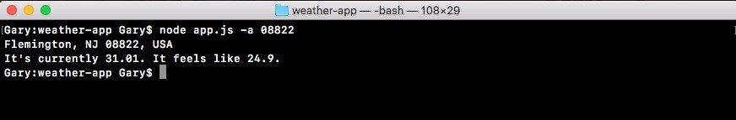

When we run it we get

Flemington, NJ

as the formatted address and

It's currently

is 31.01. It feels like 24.9. Now to test that this is working we'll type in

something else inside of quotes,

something like

Key West fl

:

**node app.js -a 'Key West fl'**



And

when

we

run

this

command

we

do

get

Key

West,

FL

as

shown

as

the

formatted address, and It's currently 64.51. It feels like 64.52.

With this in place, the weather application is now wired up. We take the address we get the latitude/longitude pair using the Google Geocoding API. Then we use our forecast API to take that latitude/longitude pair and convert it into temperature information.

**Summary**

In this chapter, we learned about how to set up yargs for the weather-app file and how to include user input in it. Next, we looked into how to handle errors inside of our callback functions and how to recover from those errors. We simply added else/if statements inside of the callback function. Callbacks are just one function, so in order to figure out if things went well or if things didn't go well, we have to use else/if statements, this lets us do different things, such as print different messages, depending on whether or not we perceive the request to have gone well. Then, we made our first request to the weather API, and we looked into a way to fetch the weather based off of the latitude-longitude combination.

Last, we looked in chaining the geocodeAddress and getWeather call functions. We took that request call that was originally in app.js, and we moved it into weather.js, defining it there. We used a callback to pass the data from weather.js into app.js where we imported the weather.js file. Then, inside of the callback for geocodeAddress we call getWeather and inside of that callback we printed the weather specific information to the screen. This was all done using callback functions.

In the next chapter, we'll talk about a different way we can synchronize our asynchronous code using ES6 promises.

**Promises in Asynchronous Programming**

In the previous two chapters, we looked at many important concepts of asynchronous programming in Node. This chapter is about promises. Promises are available in JavaScript since ES6. Although they have been around in thirdparty libraries for quite some time, they finally made their way into the core JavaScript language, which is great because they're a really fantastic feature.

In this chapter, we'll learn about how promises work, we'll start to understand exactly why they're useful, and why they've even come to exist inside JavaScript. We'll take a look at a library called axios that supports promises. This will let us simplify our code, creating our promise calls easily. We'll actually rebuild an entire weather app in the last section.

Specifically, we'll look into following topics:

Introduction to ES6 promises

Advanced promises

Weather app with promises

**Introduction to ES6 promises**

Promises aim to solve a lot of the problems that come up when we have a lot of asynchronous code in our application. They make it a lot easier to manage our asynchronous computations—things such as requesting data from a database. Alternatively, in the case of a weather app, things such as fetching data from a

URL.

In the app.js file we do a similar thing using callbacks:

const yargs = require('yargs');

const geocode = require('./geocode/geocode'); const weather = require('./weather/weather');

const argv = yargs .options({ a: { demand: true, alias: 'address', describe: 'Address to fetch weather for', string: true

}

})

.help()

.alias('help', 'h')

.argv;

geocode.geocodeAddress(argv.address, (errorMessage, results) => { if (errorMessage) { console.log(errorMessage);

} else {

console.log(results.address); weather.getWeather(results.latitude, results.longitude, (errorMessage, weatherResul if (errorMessage) { console.log(errorMessage);

} else {

console.log(`It's currently ${weatherResults.temperature}. It feels like ${weat

}

});

}

});

In this code, we have two callbacks:

One that gets passed into geocodeAddress

One that gets passed into getWeather

We use this to manage our asynchronous actions. In our case, it's things such as fetching data from an API, using an HTTP request. We can use promises in this example to make the code a lot nicer. This is exactly the aim later in the chapter.

In this section, we'll explore the basics concept of promises. We'll compare and contrast callbacks with promises just yet, because there's a lot more subtleties than can be described without knowing exactly how promises work. So, before we talk about why they're better, we will simply create some.

**Creating an example promise**

In the Atom, inside the playground folder, we'll create a new file and call it promise.js. Before we define promises and talk about exactly how they work, we will run through a simple example because that is the best way to learn just about anything—going through an example and seeing how it works.

To get started, we'll work through a very basic example. We'll stick to the core promise features.

To get started with this very simple example, we'll make a variable called somePromise. This will eventually store the promise object. We'll be calling various methods on this variable to do something with the promise. We'll set the somePromise variable equal to the return result from the constructor function for promises. We'll use the new keyword to create a new instance of a promise. Then, we'll provide the thing we want to create a new instance of, Promise, as shown here: var somePromise = new Promise

Now this Promise function, which is indeed a function—we have to call it like one; that is, it takes one argument. This argument will be a function. We'll use an anonymous arrow function (=>), and inside it, we'll do all of the asynchronous stuff we want to do:

var somePromise = new Promise(() => {

});

It will all be abstracted, kind of like we abstract the HTTP request inside the geocodeAddress function in the geocode.js file:

const request = require('request');

var geocodeAddress = (address, callback) => { var encodedAddress = encodeURIComponent(address);

request({ url: `https://maps.googleapis.com/maps/api/geocode/json?address=${encodedAddress}`, json: true

}, (error, response, body) => { if (error) {

callback('Unable to connect to Google servers.'); } else if (body.status === 'ZERO_RESULTS') { callback('Unable to find that address.'); } else if (body.status === 'OK') { callback(undefined, { address: body.results[0].formatted_address, latitude: body.results[0].geometry.location.lat, longitude: body.results[0].geometry.location.lng

});

}

}); }; module.exports.geocodeAddress = geocodeAddress;

All of the complex logic in the geocodeAddress function does indeed need to happen, but the app.js file doesn't need to worry about it. The geocode.geocodeAddress function in the app.js file has a very simple if statement that checks whether there's an error. If there is an error, we will print a message, and if there's not, we move on. The same thing will be true with promises.

The new Promise callback function will get called with two arguments, resolve and reject:

var somePromise = new Promise((resolve, reject) => {

});

This is how we'll manage the state of our promise. When we make a promise, we're making a promise; we're saying, "Hey, I'll go off and I'll fetch that website data for you." Now this could go well, in which case, you will resolve the promise, setting its state to fulfilled. When a promise is fulfilled, it's gone out and it's done the thing you've expected it to do. This could be a database request, an HTTP request, or something else completely.

Now when you call reject, you're saying, "Hey, we tried to get that thing done man, but we just could not." So the promise has been considered rejected. These are the two states that you can set a promise to—fulfilled or rejected. Just like inside geocode.js, we either provide one argument for an error, or we provide the second argument if things went well. Instead of doing that though, promises give us two functions we can call.

Now, in order to illustrate exactly how we can use these, we'll call resolve. Once again, this is not asynchronous. We're not doing anything quite yet. So all of this will happen essentially in real time, as far as you see in Terminal. We'll call resolve with some data. In this case, I'll pass in a string, Hey. It worked!, as shown here:

var somePromise = new Promise((resolve, reject) => { resolve('Hey. It worked!');

});

Now this string is the value the promise was fulfilled with. This is exactly what someone will get back. In case of the geocode.geocodeAddress function in app file, it could be the data, whether it's the results or the error message. In our case though, we're using resolve, so this will be the actual data the user wanted. When things go well, Hey. It worked! is what they expect.

*Now you can only pass one argument to both resolve and reject, which means that if you want to provide multiple pieces of information I recommend that you resolve or reject an object that you can set multiple properties on. In our case though, a simple message, Hey. It worked!, will do the job.*

**Calling the promise method then**

Now in order to actually do something when the promise gets either resolved or rejected, we need to call a promise method called then; somePromise.then. The then method lets us provide callback functions for both success and error cases. This is one of the areas where callbacks differ from promises. In a callback, we had one function that fired no matter what, and the arguments let us know whether or not things went well. With promises we'll have two functions, and this will be what determines whether or not things went as planned.

Now before we dive into adding two functions, let's start with just one. Right here, I'll call then, passing in one function. This function will only get called if the promise gets fulfilled. This means that it works as expected. When it does, it will get called with the value passed to resolve. In our case, it's a simple message, but it can be something like a user object in the case of a database request. For now though, we'll stick with message:

somePromise.then((message) => {

})

This will print message to the screen. Inside the callback, when the promise gets fulfilled we'll call console.log, printing Success, and then as a second argument, we'll print the actual message variable:

somePromise.then((message) => { console.log('Success: ', message); })

**Running the promise example in Terminal**

Now that we have a very basic promise example in place, let's run it from the Terminal using nodemon, which we installed in the previous chapter. We'll add nodemon, and then we'll go into the playground folder, /promise.js:

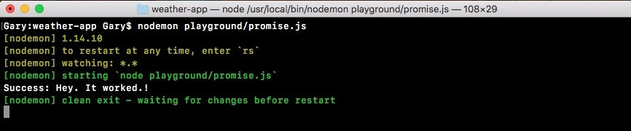

When we do this right away, our app runs and we get success. Hey. It worked! This happens instantaneously. There was no delay because we haven't done anything asynchronously. Now when we first explored callbacks (refer to Chapter 5, *Basics of Asynchronous Programming in Node.js* ), we used setTimeout to simulate a delay, and this is exactly what we'll do in this case.

Inside our somePromise function, we'll call setTimeout, passing in the two arguments: the function to call after the delay and the delay in milliseconds. I'll go with 2500, which is 2.5 seconds:

var somePromise = new Promise((resolve, reject) => { setTimeout(() => {

}, 2500);

Now after those 2.5 seconds are up, then, and only then, do we want to resolve the promise. This means that our function, the one we pass into then will not get called for 2.5 seconds. Because, as we know, this will not get called until the promise resolves. I'll save the file, which will restart nodemon:



In Terminal, you can see we have our delay, and then success: Hey it worked! prints to the screen. This 2.5 second delay was caused by this setTimeout. After the delay was up (in this case it's an artificial delay, but later it'll be a real delay), we're able to resolve with the data.

**Error handling in promises**

Now there's a chance that things didn't go well. We have to handle errors inside our Node applications. In that case, we wouldn't call resolve, we would call reject. Let's comment out the resolve line, and create a second one, where we call reject. We'll call reject much the same way we called resolve. We have to pass in one argument, and in this case, a simple error message like Unable to fulfill promise will do:

var somePromise = new Promise((resolve, reject) => { setTimeout(() => {

// resolve('Hey. It worked!'); reject('Unable to fulfill promise');

}, 2500);

});

Now when we call reject, we're telling the promise that it has been rejected. This means that the thing we tried to do did not go well. Currently, we don't have an argument that handles this. As we mentioned, this function only gets called when things go as expected, not when we have errors. If I save the file and rerun it in Terminal, what we'll get is a promise that rejects:

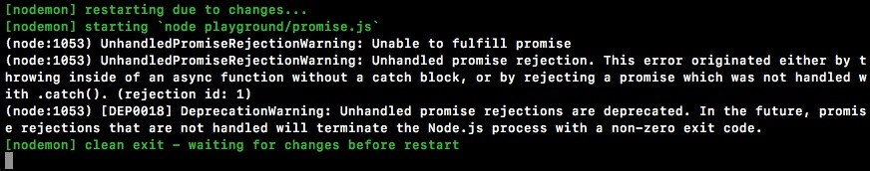

However, we don't have a handler for it, so nothing will print to the screen. This will be a pretty big problem. We need to do something with that error message. Maybe we will alert the user, or we will try some other code.

As shown in the previous code output, we can see that nothing printed between the restarting and exiting. In order to do something with the error, we'll add a second argument to the then method. This second argument is what lets us handle errors in our promises. This argument will get executed and called with that value. In this case, it's our message. We'll create an argument called errorMessage, as shown here:

somePromise.then((message) => { console.log('Success: ', message);

}, (errorMessage) => {

});

Inside the argument, we can do something with that. In this case, we'll print it to the screen using console.log, printing Error with a colon and a space to add some nice formatting, followed by the actual value that was rejected:

}, (errorMessage) => {

console.log('Error: ', errorMessage);

});

Now that we have this in place, we can refresh things by saving the file. We will now see our error message in Terminal, because we now have a place for it to do something:



Here, we have a place for it to print the message to the screen; Unable to fulfill promise prints to the screen, which works exactly as expected.

**Merits of promises**

We now have a promise that can either get resolved or rejected. If it gets resolved, meaning the promise was fulfilled, we have a function that handles that. If it gets rejected, we have a function that handles that as well. This is one of the reasons why promises are awesome. You get to provide different functions, depending on whether or not the promise got resolved or rejected. This lets you avoid a lot of complex if statements inside of our code, which we needed to do in app.js to manage whether or not the actual callback succeeded or failed.

Now inside a promise, it's important to understand that you can only either resolve or reject a promise once. If you resolve a promise you can't reject it later, and if you resolve it with one value you can't change your mind at a later point in time. Consider this example, where I have a code like the following code; here I resolve first and then I reject:

var somePromise = new Promise((resolve, reject) => { setTimeout(() => { resolve('Hey. It worked!'); reject('Unable to fulfill promise');

}, 2500); });

somePromise.then((message) => { console.log('Success: ', message);

}, (errorMessage) => {

console.log('Error: ', errorMessage);

});

In this case, we'll get our success message printing to the screen. We'll never see errorMessage, because, as I just said, you can only do one of these actions once. You can either resolve once or you can reject once. You can't do both; you can't do either twice.

This is another great advantage over callbacks. There's nothing preventing us from accidentally calling the callback function twice. Let's consider the geocode.js file for example. Let's add another line in the if block of geocode request call, as shown here:

const request = require('request');

var geocodeAddress = (address, callback) => { var encodedAddress = encodeURIComponent(address);

request({

url: `https://maps.googleapis.com/maps/api/geocode/json?address=${encodedAddress}`, json: true

}, (error, response, body) => { if (error) { callback('Unable to connect to Google servers.'); callback();

This is a more obvious example, but it could easily be hidden inside of complex if-else statements. In this case, our callback function in app.js will indeed get called twice, which can cause really big problems for our program. Inside the promise example this callback will never get called twice, no matter how many times you try to call resolve or reject, this function will only get fired once.

We can prove that right now by calling resolve again. In the promise example case, let's save the file with the following changes:

var somePromise = new Promise((resolve, reject) => { setTimeout(() => { resolve('Hey. It worked!'); resolve(); reject('Unable to fulfill promise');

}, 2500);

});

Now, let's refresh things; we'll resolve with our message, Hey. It worked! and we'll never ever have the function fired a second time with no message. Because, as we said, the promise is already resolved. Once you set a promise's state to either fulfilled or rejected, you can't set it again.

Now before a promise's resolve or reject function gets called, a promise is in a state known as pending. This means that you're waiting for information to come back, or you're waiting for your async computation to finish. In our case, while we're waiting for the weather data to come back, the promise would be considered pending. A promise is considered settled when it has been either fulfilled or rejected.

No matter which one you chose, you could say the promise has settled, meaning that it's no longer pending. In our case, this would be a settled promise that was indeed fulfilled because resolve is called right here. So these are just a couple of the benefits of promises. You don't have to worry about having callbacks called twice, you can provide multiple functions—one for success handling and one for error handling. It really is a fantastic utility!

Now that we've gone through a quick example of how promises work, going over just the very fundamentals, we'll to move on to something slightly more complex.

**Advanced promises**

In this section, we'll explore two more ways to use promises. We'll create functions that take input and return a promise. Also, we'll explore promise chaining, which will let us combine multiple promises.

**Providing input to promises**

Now the problem with the example we discussed in the previous section is that we have a promise function, but it doesn't take any input. This most likely is never going to be the case when we're using real-world promises. We'll want to provide some input, such as the ID of a user to fetch from the database, a URL to request, or a partial URL, for example, just the address component.

In order to do this, we'll have to create a function. For this example, we'll make a variable, which will be a function called asyncAdd:

var asyncAdd = () => {

}

This will be a function that simulates the async functionality using setTimeout. In reality, it's just going to add two numbers together. However, it will illustrate exactly what we need to do, later in this chapter, to get our weather app using promises.

Now in the function, we will take two arguments, a and b, and we'll return a promise:

var asyncAdd = (a, b) => {

};

So, whoever calls this asyncAdd method, they can pass in input, but they can also get the promise back so that they can use then to sync up and wait for it to complete. Inside the asyncAdd function, we'll use return to do this. We'll return the new Promise object using the exact same new Promise syntax we did when we created the somePromise variable. Now this is the same function, so we do need to provide the constructor function that gets called with both resolve and reject, just like this:

var asyncAdd = (a, b) => { return new Promise((resolve, reject) => {

});

Now we have an asyncAdd function, which takes two numbers and returns a promise. The only thing left to do is to actually simulate the delay, and make the call to resolve. To do this, we'll simulate the delay using setTimeout. Then we'll pass in my callback function, setting the delay to 1.5 seconds, or 1500 milliseconds:

return new Promise((resolve, reject) => { setTimeout(() => {

}, 1500)

});

In the callback function, we'll write a simple if-else statement that will check if the type of both a and b is a number. If it is, great! We'll resolve the value of the two numbers added. If they're not numbers (one or more), then we'll reject. To do this, we'll use the if statement with the typeof operator:

setTimeout(() => { if (typeof a === 'number')

}, 1500);

Here, we're using the typeof object to get the string type before the variable. Also, we're checking whether it's equal to a number, which is what will come back from typeof when we have a number. Now similar to a, we'll add typeof b, which is also a number: if (typeof a === 'number' && typeof b === 'number') {}

We can add the two numbers up, resolving the value. Inside the code block of the if statement, we'll call resolve, passing in a + b:

return new Promise((resolve, reject) => { setTimeout(() => { if (typeof a === 'number' && typeof b === 'number') { resolve(a + b);

}

}, 1500);

This will add the two numbers up, passing in one argument to resolve. Now this is the happy path when both a and b are indeed numbers. If things don't go well, we'll want to add reject. We'll use the else block to do this. If the previous condition fails, we'll reject by calling reject('Arguments must be numbers'):

if (typeof a === 'number' && typeof b === 'number') { resolve(a + b); } else {

reject('Argumets must be numbers'); }

Now we have an asyncAdd function that takes two variables, a and b, returns a promise, and anyone who happens to call asyncAdd can add a then call onto the return result to get that value.

**Returning the promises**

Now what exactly will this look like? To show this, first we'll comment out all of the code we have in the newPromise variable of promise.js. Following this, we'll call the asyncAdd variable where we make asyncAdd. We'll call it like we would any other function, by passing in two values. Remember, this could be a database ID or anything else for an async function. In our case, it's just two numbers. Let's say, 5 and 7. Now the return value from this function is a promise. We can make a variable and call then on that variable, but we can also just tack the then method, as shown here: asyncAdd(5, 7).then

This is exactly what we'll do when we use promises; we'll tack on then, passing in our callbacks. The first callback being the success case, and the second one being the error case:

ouldasyncAdd(5, 7).then(() => { }, () => {

});

In the second callback, we'll get our errorMessage, which we can log to the screen using the console.log(errorMessage); statement, as shown here:

asyncAdd(5, 7).then(() => {

}, (errorMessage) => { console.log(errorMessage);

});

If one or more of the numbers are not actually numbers, the error function will fire because we called reject. If both are numbers, all we'll do will get the result and print it to the screen, using console.log. We'll add res and inside the arrow function (=>), we'll add the console.log statement and print the string Result with a colon. Then, as the second argument in console.log, we'll pass in the actual number, which will print it to the screen as well:

asyncAdd(5, 7).then(() => { console.log('Result:', res); }, (errorMessage) => { console.log(errorMessage); });

Now that we have our promise asyncAdd function in place, let's test this out inside Terminal. To do this, we'll run nodemon to start up nodemon playground/promise.js:

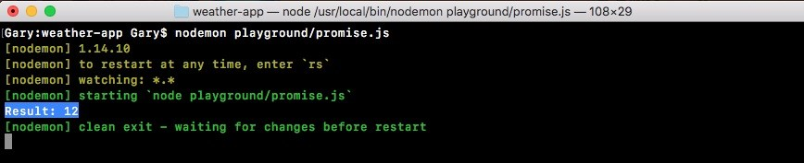

Right away, we'll get the delay and the result, 12 prints to the screen. This is fantastic! We are able to create the function that takes the dynamic input, but still returns a promise.

Now notice that we've taken an async function that usually requires callbacks and we've wrapped it to use promises. This is a good handy feature. As you start using promises in Node, you'll come to realize that some things do not support promises and you'd like them to. For example, the request library that we used to make our HTTP requests does not support promises natively. However, we can wrap our request call inside of a promise, which is what we'll to do later in the section. For now though, we have a basic example illustrating how this works.

Next, we'd like to talk about promise chaining.

**Promise chaining**

Promise chaining is the idea of having multiple promises run in a sequence. For example, I want to take an address and convert that into coordinates, and take those coordinates and convert them into weather information; this is an example of needing to synchronize two things. Also, we can do that really easily using promise chaining.

In order to chain our promises, inside our success call we'll return a new promise. In our example, we can return a new promise by calling asyncAdd again. I'll call asyncAdd next to the res and console.log statements, passing in two arguments: the result, whatever the previous promise has returned, and some sort of new number; let's use 33:

asyncAdd(5, 7).then((res) => { console.log('Result:', res); return asyncAdd(res, 33);

Now we're returning a promise so we can add my chaining onto it by calling the then method again. The then method will to get called after we close the closing parenthesis for our previous then method. This will also take one or more arguments. We can pass in a success handler, which will be a function and an error handler, which will also be a function:

asyncAdd(5, 7).then((res) => { console.log('Result:', res); return asyncAdd(res, 33); }, (errorMessage) => { console.log(errorMessage);

}).then(() => {

}, () => {

})

Now that we have our then callbacks set up, we can actually fill them out. Once again we will get a result; this will be the result of 5 plus 7, which is 12, plus 33, which will be 45. Then, we can print console.log ('Should be 45'). Next, we'll print the actual value from results variable:

}).then((res) => {

console.log('Should be 45', res);

}, () => {

});

Now our error handler will also be the same. We'll have errorMessage and we'll print it to the screen using the console.log, printing errorMessage:

}).then((res) => {

console.log('Should be 45', res);

}, (errorMessage) => { console.log(errorMessage);

});

Now what we have is some chaining. Our first then callback functions will fire based on the result of our first asyncAdd call. If it goes well, the first one will fire. If it goes poorly, the second function will fire. Our second then call will be based on the asyncAdd call, where we add 33. This will let us chain the two results together, and we should get 45 printing to the screen. We'll save this file, which will restart things inside nodemon. Eventually, we'll get our two results: 12 and our

Should be 45. As shown in the following code image, we get just that, Result: 12 and Should be 45, printing to the screen:

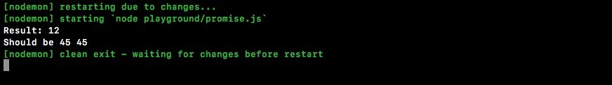

**Error handling in promises chaining**

Now when it comes to error handling, there are a few quirks; so, we'll simulate some errors. First up, let's simulate an error in our second asyncAdd call. We know we can do that by passing in a value that's not a number. In this case, let's wrap 33 inside quotes:

asyncAdd(5, 7).then((res) => { console.log('Result:', res); return asyncAdd(res, '33'); }, (errorMessage) => { console.log(errorMessage); }).then((res) => {

console.log('Should be 45', res);

}, (errorMessage) => { concole.log(errorMessage);

})

This will be a string and our call should reject. Now we can save the file and see what happens:

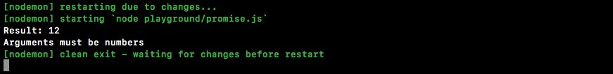

We get Result: 12, then we get our error, Arguments must be numbers. Exactly as we expect, this is printing on the screen. Instead of getting Should be 45, we get our error message.

But things get a little trickier when something earlier on in the promise chain gets rejected. Let's swap '33' with the number 33. Then let's replace 7 with the string '7', as shown here:

asyncAdd(5, '7').then((res) => { console.log('Result:', res); return asyncAdd(res, 33); }, (errorMessage) => { console.log(errorMessage);

}).then((res) => {

console.log('Should be 45', res);

}, (errorMessage) => { concole.log(errorMessage);

})

This will cause our first promise to fail, which means we'll never see the result. We should see the error message printing to the screen, but that's not what will happen:

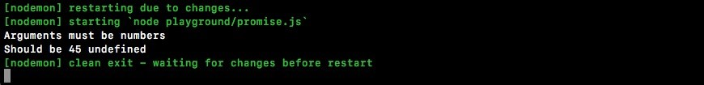

When we restart, we do indeed get the error message printing to the screen, but then we also get Should be 45 undefined. The second then console.log is running because we provided an error handler in the second asyncAdd function. It's running the error handler. Then it says, *Okay, things must be good now we ran the error handler. Let's move on to the next then call calling the success case*.

**The catch method**

To fix the error, we can remove both of our error handlers from both the then calls, and replace them with a call at the very bottom, to a different method, which we'll call .catch:

asyncAdd(5, '7').then((res) => { console.log('Result:', res); return asyncAdd(res, 33); }).then((res) => {

console.log('Should be 45', res);

}).catch;

The catch promise method is similar to then, but it just takes one function. This is the error handler. As shown in the following code, we can specify one error handler if any of our promise calls fail. We'll take errorMessage and print it to the screen using console.log(errorMessage):

asyncAdd(5, '7').then((res) => { console.log('Result:', res); return asyncAdd(res, 33); }).then((res) => {

console.log('Should be 45', res); }).catch((errorMessage) => { console.log(errorMessage)

});

For now though, if things are a little blurry that is okay, as long as you're starting to see exactly what we're doing. We're taking the result from one promise and passing it to a different one. In this case, the result works exactly as expected.

The first promise fails, we get, Arguments must be numbers printing to the screen. Also, we don't get that broken statement where we try to print 45, but we get undefined instead. Using catch, we can specify an error handler that will fire for all of our previous failures. This is exactly what we want.

**The request library in promises**

Now as I mentioned earlier, some libraries support promises while others don't. The request library does not support promises. We will make a function that wraps request, returning a promise. We'll use some functionalities from the geocode.js file from the previous chapter.

First, let's discuss a quick setup, and then we'll actually fill it out. In the playground folder, we can make a new file to store this, called promise-2.js:

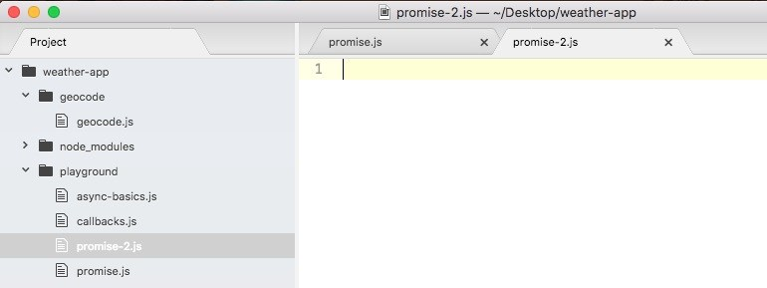

We'll make a function called geocodeAddress. The geocodeAddress function will take the plain text address, and it will return a promise:

var geocodeAddress = (address) => {

};

The geocodeAddress function will return a promise. So if I pass in a ZIP code, such as 19146, I would expect a promise to come back, which I can attach a then call to. This will let me wait for that request to finish. Right here, I'll tack on a call to then, passing in my two functions: the success handler for when the promise is fulfilled and the error handler for when the promise is rejected: geocodeAddress('19146').then(() => {

}, () => {

})

Now when things go well, I'll expect the location object with the address, the latitude, and the longitude, and when things go poorly, I'll expect the error message:

geocodeAddress('19146').then((location) => {

}, (errorMessage) => {

})

When the error message happens, we'll just print it to the screen using console.log (errorMessage). For now, when things go well and the success case runs, we'll just print that entire object using our pretty printing technique, console.log. Then, we'll call JSON.stringify, like we've done many times before, passing in the three arguments—the object, undefined for the filter method—which we'll never use in the book, and the number 2 for the number of spaces we'd like to use as our indentation:

geocodeAddress('19146').then((location) => { console.log(JSON.stringify(location, undefined, 2));

}, (errorMessage) => { console.log(errorMessage);

});

This is what we want to create, the function that lets this functionality work as expected. This then call should work as shown in the previous code.

To get started I'll return the promise by calling: return new Promise, passing in my constructor function:

var geocodeAddress = (address) => { return new Promise(() => {

});

};

Inside the function, we'll add that call to request. Let's provide the resolve and reject arguments:

return new Promise((resolve, reject) => {

});

};

Now that we have our Promise set up, we can load in the request module on top of the code, creating a constant called request and setting that equal to the return result from require('request'):

const request = require('request'); var geocodeAddress = (address) => {

Next, we'll move into the geocode.js file, grab code inside the geocodeAddress function, and move it over into promise-2 file, inside of the constructor function:

const request = require('request'); var geocodeAddress = (address) => { return new Promise((resolve, reject) => { var encodedAddress = encodeURIComponent(address);

request({ url: `https://maps.googleapis.com/maps/api/geocode/json?address=${encodedAddress}`, json: true

}, (error, response, body) => { if (error) { callback('Unable to connect to Google servers.'); } else if (body.status === 'ZERO_RESULTS') { callback('Unable to find that address.'); } else if (body.status === 'OK') { callback(undefined, { address: body.results[0].formatted_address, latitude: body.results[0].geometry.location.lat, longitude: body.results[0].geometry.location.lng

});

}

});

});

};

Now we are mostly good to go; we only need to change a few things. The first thing we need to do is to replace our error handlers. In the if block of the code, we have called our callback handler with one argument; instead, we'll call reject, because if this code runs, we want to reject the promise. We have the same thing in the next else block. We'll call reject if we get ZERO_RESULTS. This is indeed a failure, and we do not want to pretend we succeeded:

if (error) { reject('Unable to connect to Google servers.'); } else if (body.status === 'ZERO_RESULTS') { reject('Unable to find that address.');

Now in the next else block, this is where things did go well; here we can call resolve. Also, we can remove the first argument, as we know resolve and reject only take one argument:

if (error) { reject('Unable to connect to Google servers.');

} else if (body.status === 'ZERO_RESULTS') { reject('Unable to find that address.'); } else if (body.status === 'OK') { resolve(

We are able to specify multiple values though, because we resolve an object with properties on it. Now that we have this in place, we are done. We can actually save our file, rerun it inside Terminal, and test things out.

**Testing the request library**

To test, we'll save the file, move into Terminal, and shut down nodemon for the promise.js file. We'll run node for the promise.js file. It's in the playground folder, and it's called promise-2.js: **node playground/promise-2.js**

Now, when we run this program, we're actually making that HTTP request. As shown in the following code output, we can see the data comes back exactly as we expected:

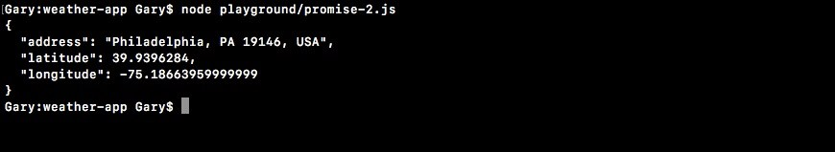

We get our address, latitude, and longitude variables. This is fantastic! Now let's test to see what happens when we pass in an invalid address, something like 5 zeroes, which we've used before to simulate an error:

const request = require('request');

var geocodeAddress = (address) => { return new Promise((resolve, reject) => { var encodedAddress = encodeURIComponent(address);

request({ url: `https://maps.googleapis.com/maps/api/geocode/json?address=${encodedAddress}`, json: true

}, (error, response, body) => { if (error) { reject('Unable to connect to Google servers.');

} else if (body.status === 'ZERO_RESULTS') { reject('Unable to find that address.'); } else if (body.status === 'OK') { resolve({ address: body.results[0].formatted_address, latitude: body.results[0].geometry.location.lat, longitude: body.results[0].geometry.location.lng

});

}

});

});

};

We'll save the file, rerun the program, and Unable to find that address. prints to the screen:



This happens only because we call reject. We will call reject inside of the Promise constructor function. We have our error handler, which prints the message to the screen. This is an example of how to take a library that does not support promises and wrap it in a promise, creating a promise ready function. In our case, that function is geocodeAddress.

**Weather app with promises**

In this section, we'll learn how to use a library that has promises built in. We'll explore the axios library, which is really similar to request. Although, instead of using callbacks as request does, it uses promises. So we don't have to wrap our calls in promises to get that promise functionality. We'll actually be recreating the entire weather app in this section. We'll only have to write about 25 lines of code. We'll go through the entire process: taking the address, getting the coordinates, and then fetching the weather.

**Fetching weather app code from**

**the app.js file**

To fetch weather app code from the app.js file, we'll duplicate app.js, because we configure yargs in the original app.js file and we'll want to carry the code over to the new project. There's no need to rewrite it. In the weather directory, we'll duplicate app.js, giving it a new name, app-promise.js.

Inside app-promise.js, before we add anything, let's rip some stuff out. We'll be ripping out the geocode and weather variable declarations. We'll not be requiring any files:

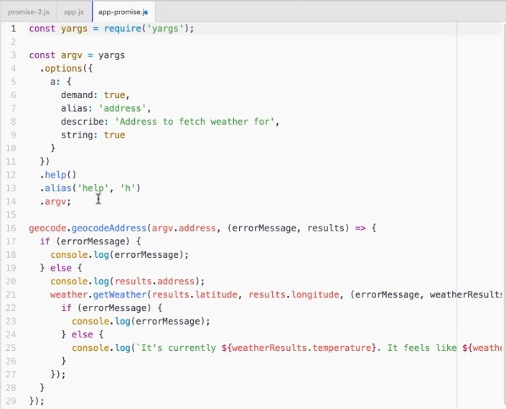

Then I'll remove everything after our yargs configuration, which in this case is just our call to geocodeAddress. The resultant code will look like the following:

const yargs = require('yargs');

const argv = yargs .options({ a: { demand: true, alias: 'address', describe: 'Address to fetch weather for', string: true

}

})

.help()

.alias('help', 'h')

.argv;

**Axios documentations**

Now that we have a clean slate, we can get started by installing the new library. Before we run the npm install command, we'll see where we can find the documentation. We can get it by visiting: <https://www.npmjs.com/package/axios>. As shown in the following screenshot, we have the axios npm library page, where we can view all sorts of information about it, including the documentation:

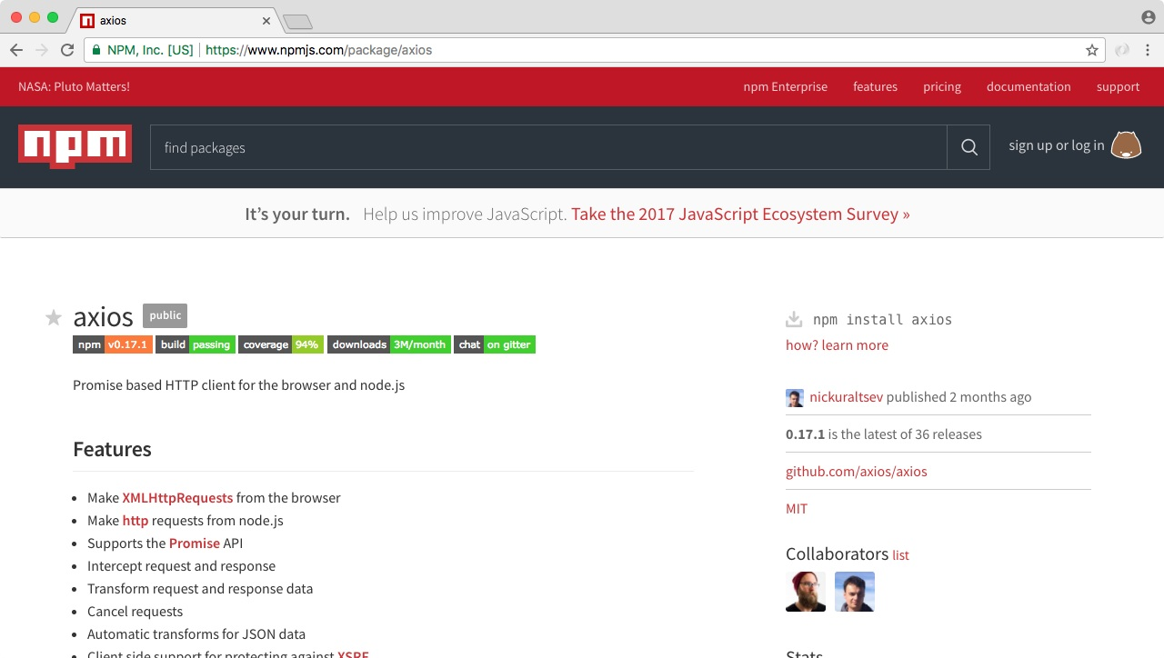

Here we can see some things that look familiar. We have calls to then and catch, just like we do when we use promises outside of axios:

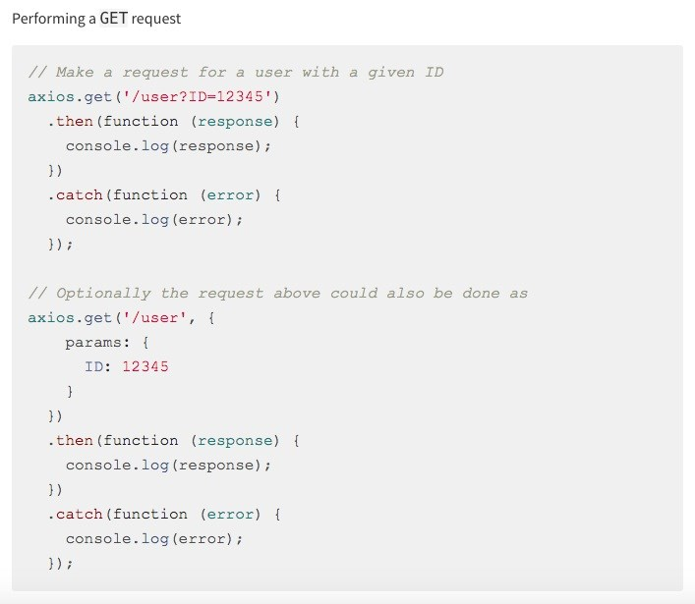

Inside the stats column of this page, you can see that this is a super popular library. The most recent version is 0.13.1. This is the exact version we'll be using. Feel free to go to this page when you use axios in your projects. There are a lot of really good examples and documentation. For now though, we can install it.

**Installing axios**

To install axios, inside Terminal, we'll be running npm install; the library name is axios, and we'll specify the version 0.17.1 with the save flag updating the package.json file. Now I can run the install command, to install axios:

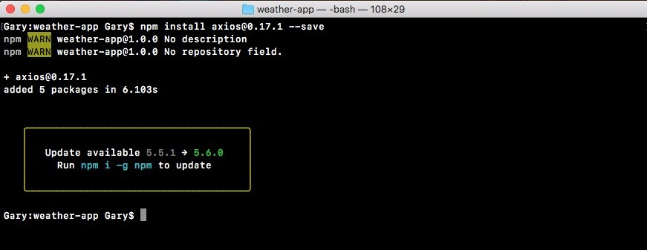

**Making calls in the app-promise**

**file**

Inside our app-promise file, we can get started by loading in axios at the top. We'll make a constant called axios, setting it equal to require('axios'), as shown here:

const yargs = require('yargs'); const axios = require('axios');

Now that we have this in place, we can actually start making the calls in the code. This will involve us pulling out some of the functionality from the geocode and weather files. So we'll open up the geocode.js and weather.js files. Because we will be pulling some of the code from these files, things such as the URL and some of the error handling techniques. Although we'll talk about the differences as they come up.

The first thing we need to do is to encode the address and get the geocode URL.

Now this stuff happens inside geocode.js. So we'll actually copy the encodedAddress variable line, where we create the encoded address, and paste it in the app-promise file, following the argv variable:

.argv; var encodedAddress = encodeURIComponent(argv.address);

Now we do need to tweak this a little bit. The address variable doesn't exist; but we have argv.address. So, we'll switch address with argv.address: var encodeAddress = encodeURIComponent(argv.address);

Now we have the encoded address; the next thing we need to get before we can start using axios is the URL that we want to make the request to. We'll grab that from the geocode.js file as well. In app-promise.js, we will make a new variable called geocodeURI. Then, we'll take the URL present in geocode.js, from the opening tick to the closing tick, copy it, and paste it in app-promise.js, equal to geocodeURI:

var encodedAddress = encodeURIComponent(argv.address); var geocodeUrl = `https://maps.googleapis.com/maps/api/geocode/json?address=${encodedAd

Now we use the encoded address variable inside the URL; this is fine because it does exist in our code. So at this point, we have our geocodeUrl variable and we can get started in making our very first axios request.

**Making axios request**

In our case, we'll be taking the address and getting the latitude and longitude. To make our request, we'll call a method available on axios, axios.get:

var geocodeUrl = `https://maps.googleapis.com/maps/api/geocode/json?address=${encodedAd axios.get

The get is the method that lets us make our HTTP get request, which is exactly what we want to do in this case. Also, it's really simple to set up. When you're expecting JSON data, all you have to do is to pass in the URL that we have in the geocodeUrl variable. There's no need to provide any other options, such as an option letting it know it's JSON. axios knows how to automatically parse our JSON data. What get returns is actually a promise, which means we can use .then in order to run some code when the promise gets fulfilled or rejected, whether things go well or poorly: axios.get(geocodeUrl).then()

Inside then, we'll provide one function. This will be the success case. The success case will get called with one argument, which the axios library recommends that you call response:

axios.get(geocodeUrl).then((response) => {

});

Technically, we could call anything you like. Now inside the function, we'll get access to all of the same information we got inside of the request library; things such as our headers, response, and request headers, as well as the body information; all sorts of useful info. What we really need though is the response.data property. We'll print that using console.log:

axios.get(geocodeUrl).then((response) => { console.log(response.data);

});

Now that we have this in place, we can run our app-promise file, passing in a valid address. Also, we can see what happens when we make that request.

Inside command line (Terminal), we'll use the clear command first to clear the Terminal output. Then we can run node app-promise.js, passing in an address. Let's use a valid address, for example, 1301 lombard street, philadelphia: **node app-promise.js -a '1301 lombard street philadelphia**

The request goes out. And what do we get back? We get back the results object exactly as we saw it when we used the other modules in the previous chapters:

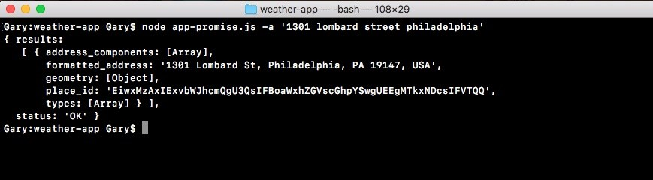

The only difference in this case is that we're using promises built in, instead of having to wrap it in promises or using callbacks.

**Error handling in axios request**

Now aside from the success handler we used in the previous example, we can also add a call to catch, to let us catch all of the errors that might occur. We'll to get the error object as the one-and-only argument; then we can do something with that error object:

axios.get(geocodeUrl).then((response) => { console.log(response.data); });catch((e) => {

});

Inside the function, we'll kick things off, using console.log to print the error argument:

}).catch((e) => { console.log(e)

});

Now let's simulate an error by removing the dot in the URL:

var encodedAddress = encodeURIComponent(argv.address);

var geocodeUrl = `https://mapsgoogleapis.com/maps/api/geocode/json?address=${encodedAdd

axios.get(geocodeUrl).then((response) => { console.log(response.data);

}).catch((e) => { console.log(e) });

We can see what happens when we rerun the program. Now I'm doing this to explore the axios library. I know exactly what will happen. This is not why I'm doing it. I'm doing it to show you how you should approach new libraries. When you get a new library, you want to play around with all the different ways it works. What exactly comes back in that error argument when we have a request that fails? This is important information to know; so when you write a real-world app, you can add the appropriate error handling code.

In this case, if we rerun the exact same command, we'll get an error:

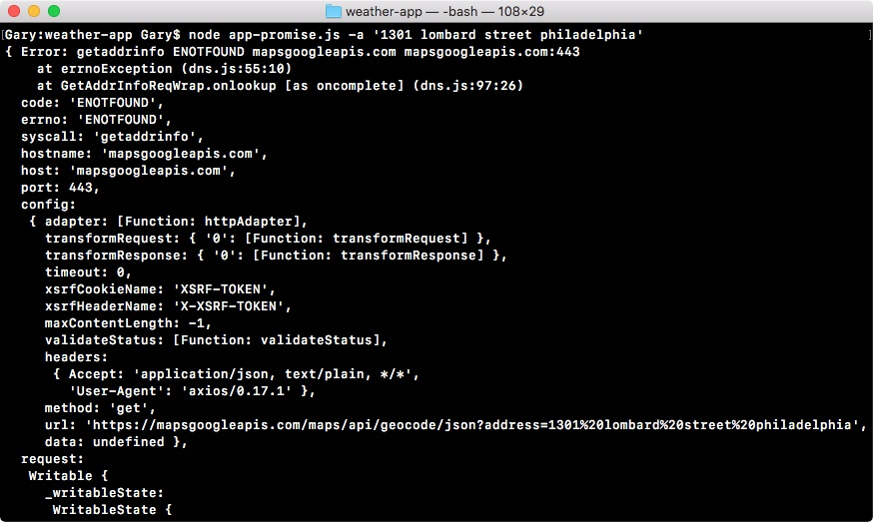

As you can see, there really is nothing to print on the screen. We have a lot of very cryptic error codes and even the errorMessage property, which usually contains something good or does not. Then we have an error code followed by the URL. What we want instead is print a plain text English message.

To do this, we'll use an if-else statement, checking what the code property is. This is the error code and in this case ENOTFOUND; we know it means that it could not connect to the server. In app-promise.js, inside the error handler, we can add this by having if and checking the condition:

}).catch((e) => { if (e.code === 'ENOTFOUND') {

}

If that is the case, we'll print some sort of custom message to the screen using console.log:

}).catch((e) => {

if (e.code === 'ENOTFOUND') { console.log('Unable to connect to API servers.');

}

console.log(e); });

Now we have an error handler that handles this specific case. So we can remove our call to console.log:

axios.get(geocodeUrl).then((response) => { console.log(response.data);

}).catch((e) => {

if (e.code === 'ENOTFOUND') { console.log('Unable to connect to API servers.');

}

});

Now if we save the file, and rerun things from Terminal, we should get a much nicer error message printing to the screen:

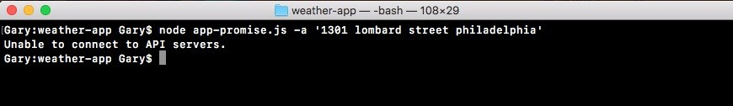

This is exactly what we get: Unable to connect to API servers. Now I'll add that dot back in, so things start working. We can worry about the response that comes back.

**Error handling with**

**ZERO_RESULT body status**

As you remember, inside the geocode file, there were some things we needed to do. We've already handled the error related to server connection, but there is still another error pending, that is, if the body.status property equals ZERO_RESULTS. We want to print an error message in that case.

To do this, we'll inside app-promise, create our very own error. We'll throw an error inside the axios.get function. This error will cause all of the code after it, not to run. It will move right into the error handler.

Now we only want to throw an error if the status property is set to ZERO_RESULTS.

We'll add an if statement at the very top of the get function to check if (response.data.status) equals ZERO_RESULTS:

axios.get(geocodeUrl).then((response) => { if (response.data.status === 'ZERO_RESULTS') {

}

If that is the case, then things went bad and we do not want to move on to make the weather request. We want to run our catch code we have. To throw a new error that our promise can catch, we'll use a syntax called throw new Error. This creates and throws an error letting Node know that something went wrong. We can provide our own error message, something that's readable to a user: Unable to

find that address:

axios.get(geocodeUrl).then((response) => { if (response.data.status === 'ZERO_RESULTS') { throw new Error('Unable to find that address.'); }

This is a message that'll let that user know exactly what went wrong. Now when this error gets thrown, the same catch code will run. Currently, we only have one if condition that checks whether the code property is ENOTFOUND. So we'll add an else clause: axios.get(geocodeUrl).then((response) => {

if (response.data.status === 'ZERO_RESULTS') { throw new Error('Unable to find that address.');

}

console.log(response.data);

}).catch((e) => { if (e.code === 'ENOTFOUND') { console.log('Unable to connect to API servers.');

} else {

}

});

Inside the else block, we can print the error message, which is the string we typed in the throw new Error syntax using the e. message property, as shown here:

axios.get(geocodeUrl).then((response) => { if (response.data.status === 'ZERO_RESULTS') { throw new Error('Unable to find that address.');

}

console.log(response.data);

}).catch((e) => {

if (e.code === 'ENOTFOUND') { console.log('Unable to connect to API servers.');

} else {

console.log(e.message);

}

});

If the error code is not ENOTFOUND, we'll simply print the message to the screen. This will happen if we get zero results. So let's simulate that to make sure the code works. Inside Terminal, we'll rerun the previous command passing in a zip code. At first, we'll use a valid zip code, 08822 and we should get our data back. Then we'll use an invalid one: 00000.

When we run the request with a valid address, we get this:

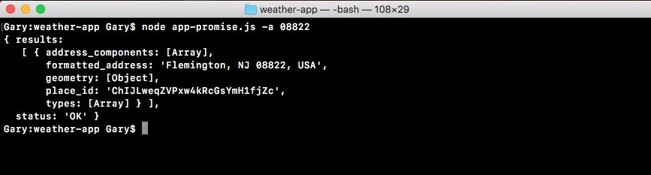

When we run the request with the invalid address, we get the error:



By calling throw new Error, we're immediately stopping the execution of this function. So console.log with e.message never prints, which is exactly what we want. Now that we have our error handler in place, we can start generating that weather URL.

**Generating the weather URL**

In order to generate the weather URL, we'll copy the URL from the weather file, taking it with the ticks in place, and moving it into the app-promise file. We'll make a new variable called weatherUrl, setting it equal to the copied URL: url: `https://api.forecast.io/forecast/4a04d1c42fd9d32c97a2c291a32d5e2d/${lat},${lng}`,

Now weatherUrl does need a few pieces of information. We need the latitude and longitude. We have two variables lat and lng, so let's create them, getting the appropriate value from that response object, var lat and var lng:

var lat; var lng; url: `https://api.forecast.io/forecast/4a04d1c42fd9d32c97a2c291a32d5e2d/${lat},${lng}`,

Now in order to pull them off, we have to go through that process of digging into the object. We've done it before. We'll be looking in the response object at the data property, which is similar to the body in the request library. Then we'll go into results, grabbing the first item and accessing the geometry property, then we'll access location.lat: var lat = response.data.results[0].geometry.location.lat;

Now similarly, we can add things for the longitude variable:

var lat = response.data.results[0].geometry.location.lat; var lng = response.data.results[0].geometry.location.lng;

Now before we make that weather request, we want to print the formatted address because that's something the previous app did as well. In our console.log(response.data) statement, and instead of printing response.data, we'll dive into the data object getting the formatted address. This is also on the results array's first item. We'll be accessing the formatted_address property:

var lat = response.data.results[0].geometry.location.lat; var lng = response.data.results[0].geometry.location.lng; var weatherUrl = `https://api.forecast.io/forecast/4a04d1c42fd9d32c97a2c291a32d5e2d/${l console.log(response.data.results[0].formatted_address);

Now that we have our formatted address printing to the screen, we can make our second call by returning a new promise. This is going to let us chain these calls together.

**Chaining the promise calls**

To get started, we'll return a call to axios.get, passing in the URL. We just defined that, it is weatherUrl:

var lat = response.data.results[0].geometry.location.lat; var lng = response.data.results[0].geometry.location.lng; var weatherUrl = `https://api.forecast.io/forecast/4a04d1c42fd9d32c97a2c291a32d5e2d/${ console.log(response.data.results[0].formatted_address); return axios.get(weatherUrl);

Now that we have this call returning, we can attach another then call right between our previous then call and catch call, by calling then, passing in one function, just like this:

return axios.get(weatherUrl);

}).then(() => {

}).catch((e) => { if (e.code === 'ENOTFOUND') {

This function will get called when the weather data comes back. We'll get that same response argument, because we're using the same method, axios.get:

}).then((response) => {

Inside the then call, we don't have to worry about throwing any errors, since we never needed to access a body property in order to check if something went wrong. With the weather request if this callback runs, then things went right. We can print the weather information. In order to get that done, we'll make two variables:

temperature apparentTemperature

The temperature variable will get set equal to response.data. Then we'll access that currently property. Then we'll access temperature. We'll pull out the second variable, the actual temperature or apparentTemperature, which is the property name, var apparentTemperature. We'll be setting this equal to response.data.currently.apparentTemperature:

}).then((response) => {

var temperature = response.data.currently.temperature; var apparentTemperature = response.data.currently.apparentTemperature;

Now that we have our two things pulled out into variables, we can add those things inside of a call, console.log. We chose to define two variables, so that we don't have to add the two really long property statements to console.log. We can simply reference the variables. We'll add console.log and we'll use template strings in the console.log statement, so that we can inject the previous mentioned two values inside of quotes: It's currently, followed by temperature. Then we can add a period, It feels like, followed by apparentTemperature:

}).then((response) => {

var temperature = response.data.currently.temperature; var apparentTemperature = response.data.currently.apparentTemperature; console.log(`It's currently ${temperature}. It feels like ${apparentTemperature}.`);

Now that we have our string printing to the screen, we can test that our app works as expected. We'll save the file and inside Terminal, we'll rerun the command from two commands ago where we had a valid zip code:

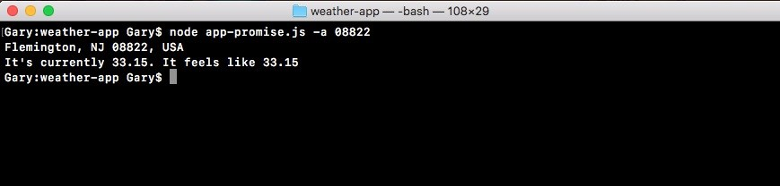

When we run this, we get the weather info for Flemington, New Jersey. It's currently 84 degrees, but it feels like 90. If we run something that has a bad address, we do get the error message:

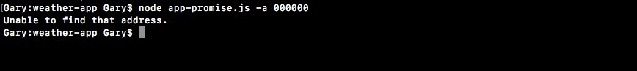

So everything looks great! Using the axios library, we're able to chain promises like the app-promise without needing to do anything too crazy. The axios get method returns a promise, so we can access it directly using then.

In the code, we use then once to do something with that geolocation data. We print the address to the screen. Then we return another promise, where we make the request for the weather. Inside of our second then call, we print the weather to the screen. We also added a catch call, which will handle any errors. If anything goes wrong with either of our promises, or if we throw an error, catch will get fired printing the messages to the screen.

This is all it takes to use axios and set up promises for your HTTP requests. Now one reason people love promises over traditional callbacks is that instead of nesting we can simply chain. So our code doesn't get indented to crazy levels. As we saw in app.js in the previous chapter, we went a few indentation levels deep just to add two calls together. If we needed to add a third it would have gotten even worse. With promises, we can keep everything at the same level, keeping our code a lot easier to maintain.

**Summary**

In this chapter, we've gone through a quick example of how promises work, by going over just the very fundamentals. Async is a critical part to Node.js. We went through the very basics of callbacks and promises. We looked a few examples, creating a pretty cool weather app.

This brings us to the end of our asynchronous Node.js programming, but this does not mean that you have to stop building out the weather app. There are a couple ideas as to what you could do to continue on with this project. First up, you can load in more information. The response we get back from the weather API contains a ton of stuff besides just the current temperature, which is what we used. It'd great if you can incorporate some of that stuff in there, whether it's high/low temperatures, or chances of precipitation.

Next up, it'd be really cool to have a default location ability. There would be a command that lets me set a default location, and then I could run the weather app with no location argument to use that default. We could always specify a location argument to search for weather somewhere else. This would be an awesome feature, and it would work kind of similar to the Notes app, where we save data to the filesystem.

In the next chapter, we'll start creating web servers, which will be async. We'll make APIs, which will be async. Also, we'll create real-time Socket.IO apps, which will be async. We'll move on to creating Node apps that we deploy to servers, making those servers accessible to anybody with a web connection.

**Web Servers in Node**

We'll cover a ton of exciting stuff in this chapter. We'll learn how to make a web server and how to integrate version control into Node applications. Now to get all this done, we will look at a framework called Express. It's one of the most popular npm libraries, and for good reason. It makes it really easy to do stuff such as creating a web server or an HTTP API. It's kind of similar to the Dark Sky API we used in the last chapter.

Now most courses start with Express, and that can be confusing because it blurs the line between what is Node and what is Express. We'll kick things off by adding Express to a brand new Node app.

Specifically, we'll cover the following topics:

Introducing Express

Static server

Rendering templates

Advanced templates

Middleware

**Introducing Express**

In this section, you'll make your very first Node.js web server, which means you'll have a whole new way for users to access your app. Instead of having them run it from the Terminal passing in arguments, you'll be able to give them a URL they can visit to view your web app or a URL they can make an HTTP request to to fetch some data.

This will be similar to what we did when we used the geocode API in the previous chapters. Instead of using an API though, we'll be able to create our own. We'll also be able to set up a static website for something like a portfolio site. Both are really valid use cases. Now all of this will be done using a library called **Express**, which is the most popular npm library. It's actually one of the reasons that Node got so popular because it was so easy to make REST APIs and static web servers.

**Configuring Express**

Express is a no-nonsense library. Now there are a lot of different ways to configure it. So it can get pretty complex. That's why we'll be using it throughout the next couple of chapters. To get started, let's make a directory where we can store all of the code for this app. This app will be our web server.

On the desktop let's us make a directory called node-web-server, by running the mkdir node-web-server command in the Terminal:

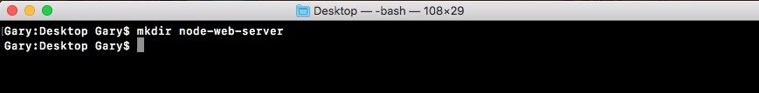

Once this directory is created, we'll navigate into it using cd:

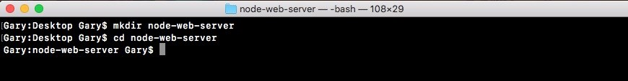

And we'll also open it up inside Atom. In Atom, we'll open it up from the desktop:

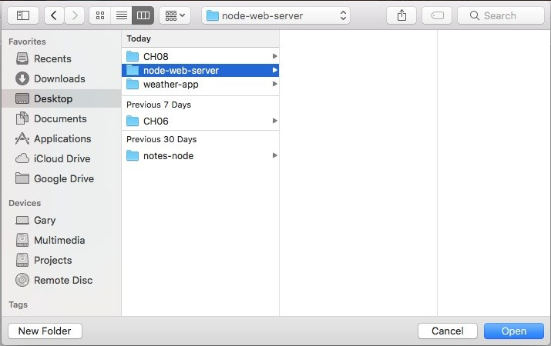

Now before going further, we'll run the npm init command so we can generate the package.json file. As shown in the following code, we'll run npm init:

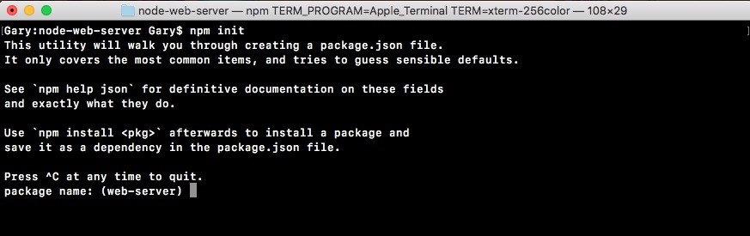

Then, we'll use the default value just by pressing *enter* through all of the options shown in the following screenshot. There's no need to customize any of these as of now:

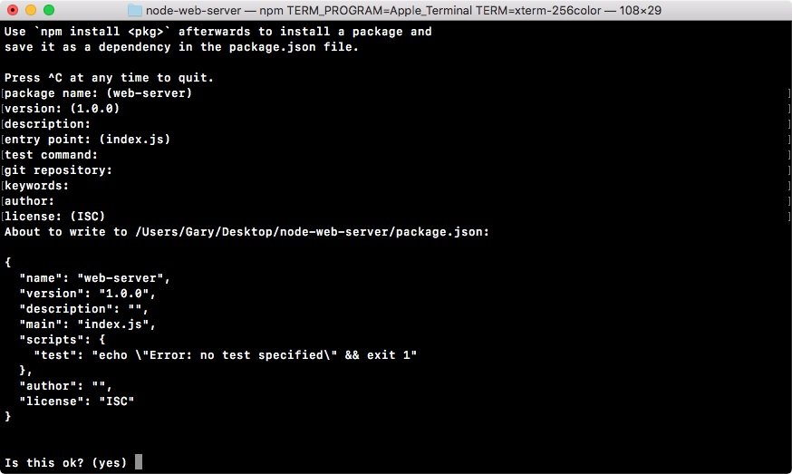

Then we'll type yes in the last statement Is this ok? (yes) and the package.json file goes in place:



**Express docs website**

As mentioned earlier, Express is a really big library. There's an entire website [dedicated to the Express docs. Instead of a simple README.md file, you can go to www .expressjs.com to view everything the website have to offer:](http://expressjs.com/)

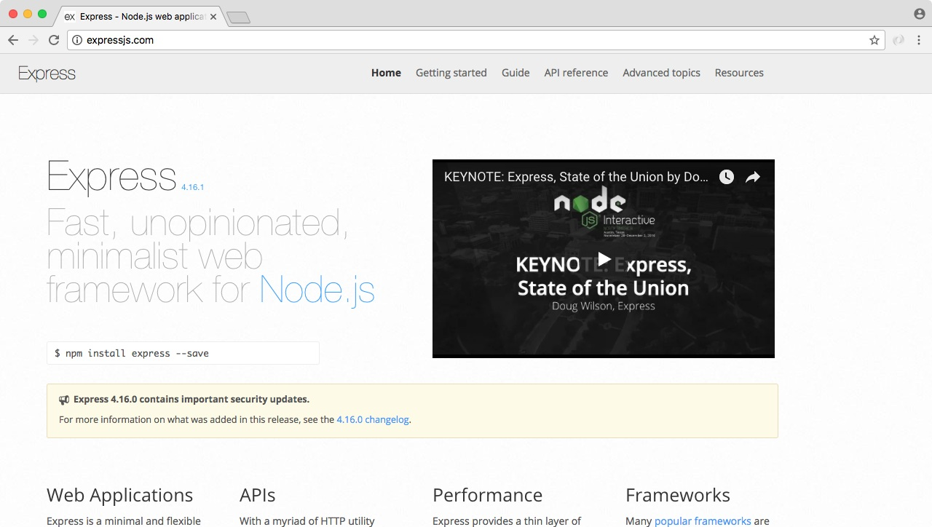

We'll find Getting started, help articles, and many more. The website has the Guide option to help you do things such as Routing, Debugging, Error handling, and an API reference, so we can look into exactly what methods we have access to and what they do. It's a very handy website.

**Installing Express**

Now that we have our node-web-server directory, we'll install Express so we can get started making our web server. In the Terminal we'll run the clear command first to clear the output. Then we'll run the npm install command. The module name is express and we'll be using the latest version, @4.16.0. We'll also provide the save

flag to update the dependencies inside of our

package.json

file as shown here:

**npm install express@4.16.0 --save**

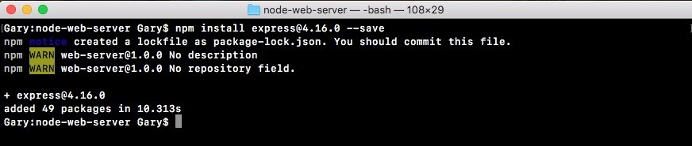

Once again we'll use the

clear

command to clear the Terminal output.

Now that we have Express installed, we can actually create our web server inside Atom. In order to run the server, we will need a file. I'll call this file server.js. It will sit right in the root of our application:

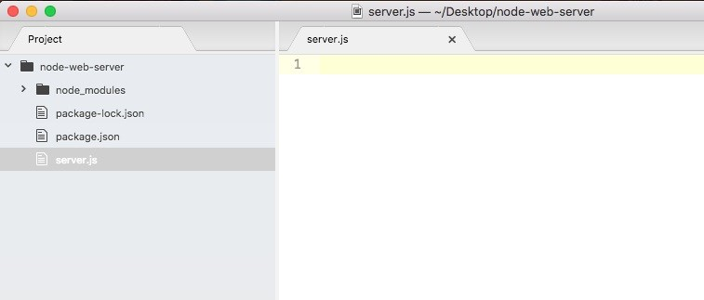

This is where we'll configure the various routes, things like the root of the website, pages like /about, and so on. It's also where we'll start the server, binding it to a port on our machine. Now we'll be deploying to a real server. Later we'll talk about how that works. For now, most of our server examples will happen on our localhost.

Inside server.js, the first thing we'll do is load in Express by making a constant called express and setting it equal to require('express'): const express = require('express');

Next up, what we'll do is make a new Express app. To do this we'll make a variable called app and we'll set it equal to the return result from calling express as a function:

const express = require('express'); var app = express();

Now there are no arguments we need to pass into express. We will do a ton of configuration, but that will happen in a different way.

**Creating an app**

In order to create an app, all we have to do is call the method. Next to the variable app we can start setting up all of our HTTP route handlers. For example, if someone visits the root of the website we're going to want to send something back. Maybe it's some JSON data, maybe it's an HTML page.

We can register a handler using app.get function. This will let us set up a handler for an HTTP get request. There are two arguments we have to pass into app.get:

The first argument is going to be a URL

The second argument is going to be the function to run; the function that tells Express what to send back to the person who made at the request

In our case we're looking for the root of the app. So we can just use forward slash (/) for the first argument. In the second argument, we'll use a simple arrow function (=>) as shown here:

const express = require('express'); var app = express();

app.get('/', (req, res) => {

};

Now the arrow function (=>) will get called with two arguments. These are really important to how Express works:

The first argument is request (req) stores a ton of information about the request coming in. Things like the headers that were used, any body information, or the method that was made with a request to the path. All of that is stored in request.

The second argument, respond (res), has a bunch of methods available so we can respond to the HTTP request in whatever way we like. We can customize what data we send back and we could set our HTTP status codes.

We'll explore both of these in detail. For now though, we'll use one method, res.send. This will let us respond to the request, sending some data back. In app.get function, let's call res.send, passing in a string. In the parenthesis we'll add Hello Express!:

app.get('/', (req, res) => { res.send('Hello Express!');

});

This is the response for the HTTP request. So when someone views the website they will see this string. If they make a request from an application, they will get back Hello Express! as the body data.

Now at this point we're not quite done. We have one of our routes set up, but the app is never going to actually start listening. What we need to do is call app.listen. The app.listen function will bind the application to a port on our machine. In this case for our local host app, we will use port 3000, a really common port for developing locally. Later in the chapter, we'll talk about how to customize this depending on whatever server you use to deploy your app to production. For now though, a number like 3000 works:

app.get('/', (req, res) => { res.send('Hello Express!');

}); app.listen(3000);

With this in place we are now done. We have our very first Express server. We can actually run things from the Terminal, and view it in the browser. Inside the Terminal, we'll use nodemon server.js to start up our app: **nodemon server.js**

This will start up the app and you'll see that the app never really finishes as shown here:

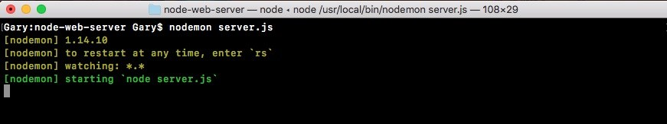

Right now it's hanging. It's waiting for requests to start coming in. The apps that use app.listen, they will never stop. You'll have to shut them down manually with *control* + *C*, like we've done before. It might crash if you have an error in your code. But it'll never stop normally, since we have that binding set up here. It will listen to requests until you tell it to stop.

Now that the server is up, we can move into the browser and open up a new tab visiting the website, localhost: followed by the port 3000:

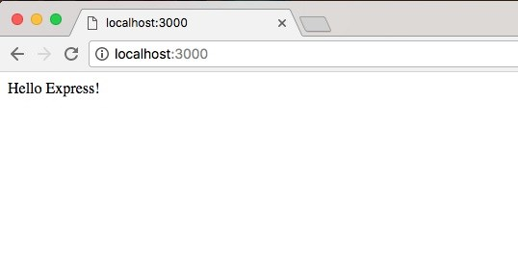

This will load up the root of the website, and we specify the handler for that route. Hello Express! shows up, which is exactly what we expected. Now there's no thrills. There's no formatting. We're just sending a string from the server back to the client that made the request.

**Exploring the developer tools in the browser for the app request**

What we'd like to do next is open up the developer tools, so we can explore exactly what happened when that request was made. Inside Chrome you can get to the Developer Tools using Settings| More Tools| Developer Tools:

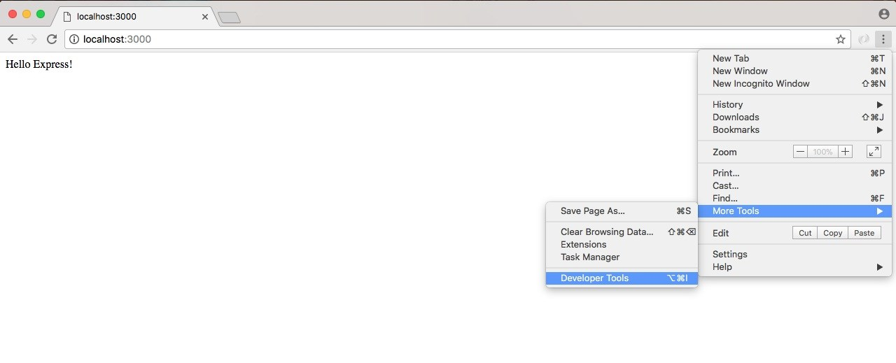

Or you can use the keyboard shortcut shown along with Developer Tools for the operating system.

*I would highly recommend memorizing that keyboard shortcut because you'll use the Developer Tools a ton in your career with*  *Node.*

We'll now open up the Developer Tools, which should look similar to the ones we used when we ran the Node Inspector debugger. They're a little different, but the idea is the same:

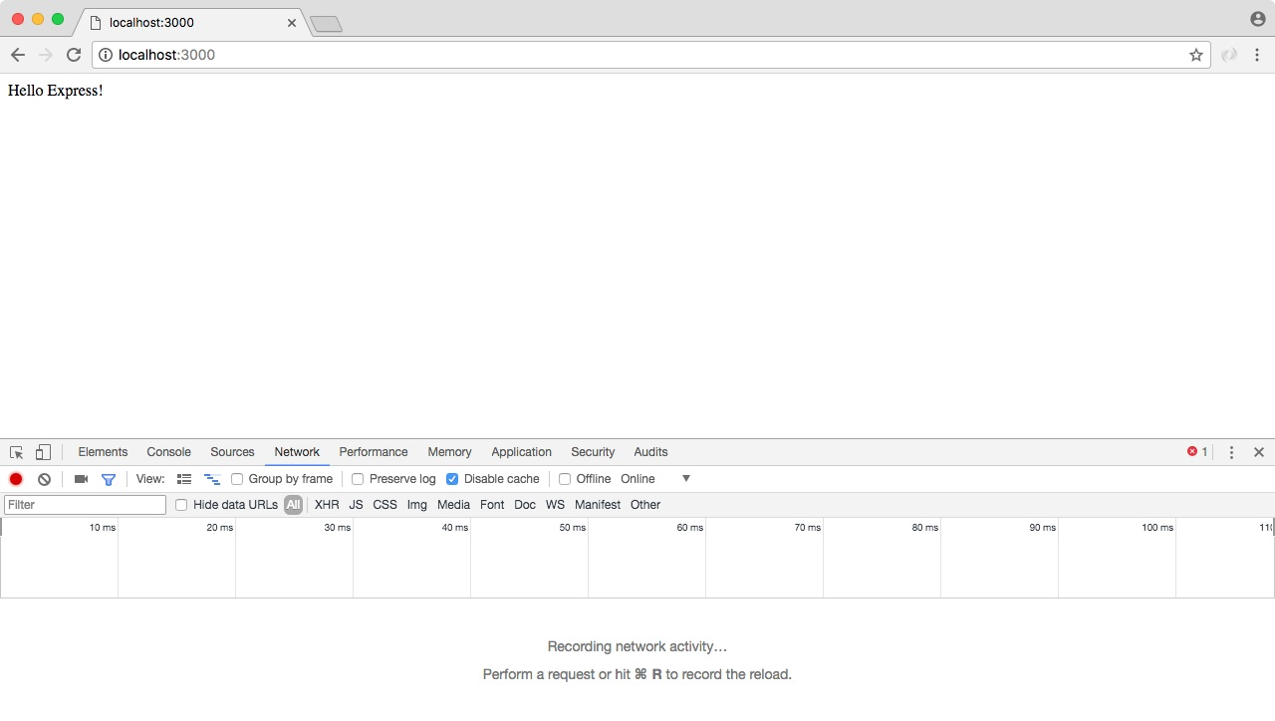

We have a bunch of tabs up top, and then we have our tab specific information down following on the page. In our case, we want to go to the Network tab, and currently we have nothing. So we'll refresh the page with the tab open, and what we see right here is our localhost request:

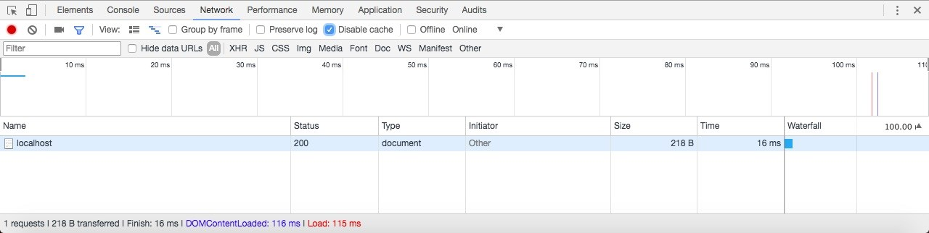

This is the request that's responsible for showing Hello Express! to the screen.

We can actually click the request to view its details:

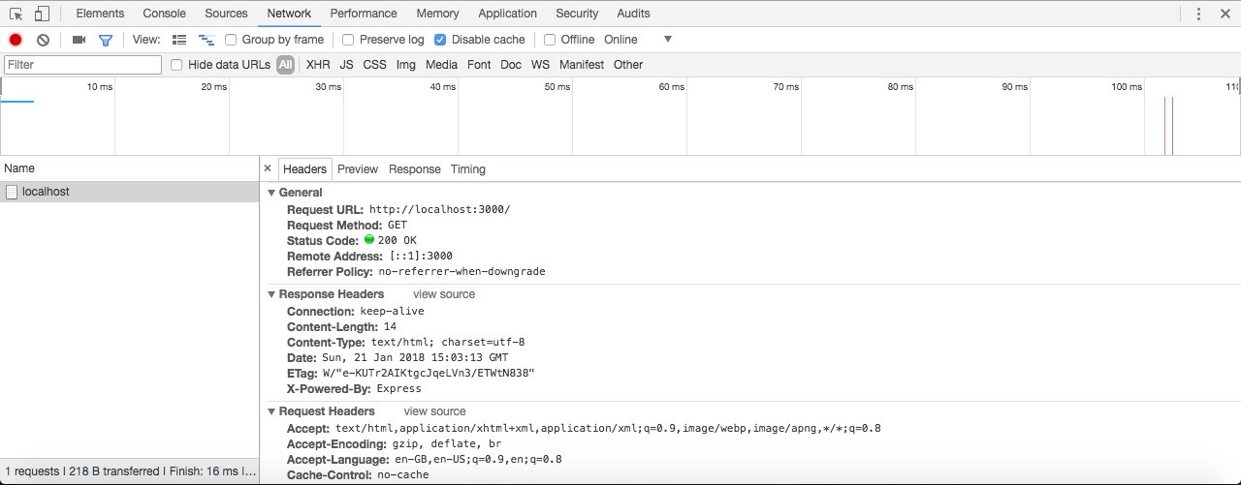

This page can be a little overwhelming at first. There is a a lot of information. Up on top we have some general info, such as the URL that was requested, the method that the client wanted; in this case, we made a GET request, and the status code that came back. The default status code being 200, meaning that everything went great. We'd like to point the attention to is one response header.

Under Response Headers we have a header called Content-Type. This header tells the client what type of data came back. Now this could be something like an HTML website, some text, or some JSON data and the client could be a web browser, an iPhone, an Android device, or any other computer with network capabilities. In our case, we're telling the browser that what came back is some HTML, so why don't you render it as such. We use the text/html Content-Type. And this automatically got set by Express, which is one of the reasons it's so popular. It handles a lot of that mundane stuff for us.

**Passing HTML to res.send**

Now that we have a very basic example, we want to step things up a notch. Inside Atom, we can actually provide some HTML right inside of send by wrapping our Hello Express! message in an h1 tag. Later in this section, we'll be setting up a static website that has HTML files that get served up. We'll also look at templating to create dynamic web pages. But for now, we can actually just pass in some HTML to res.send:

app.get('/', (req, res) => { res.send('<h1>Hello Express!</h1>');

}); app.listen(3000);

We'll save the server file, which should restart things in the browser. When we give the browser a refresh, we get Hello Express! printing to the screen:

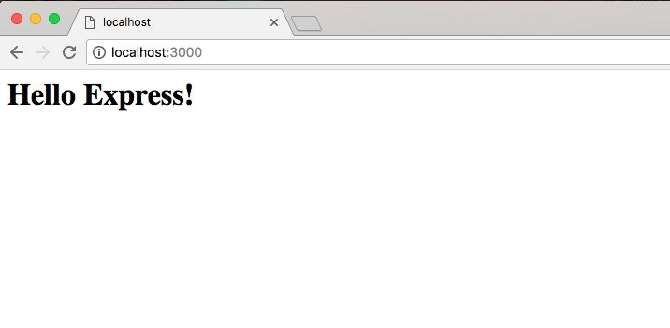

This time though, we have it in an h1 tag, which means it's formatted by the default browser styles. In this case it looks nice and big. With this in place we can now open up the request inside the Network tab, and what we get is the exact same thing we had before. We're still telling the browser that it's HTML. Only one difference this time: we actually have an HTML tag, so it gets rendered using the browser's default styles.

**Sending JSON data back**

The next thing we'd look into is how we can send some JSON data back. Sending JSON is really easy with Express. To illustrate how we can do it we'll comment out our current call to res.send and add a new one. We'll call res.send passing in an object:

app.get('/', (req, res) => {

// res.send('<h1>Hello Express!</h1>'); res.send({

})

});

On this object we can provide whatever we like. We can create a name property, setting it equal to the string version of any name, say Andrew. We can make a property called likes, setting it equal to an array, and we can specify some things we may like. Let's add Biking as one of them, and then add Cities as another:

res.send({ name: 'Andrew', likes: [ 'Biking',

'Cities'

]

});

When we call res.send passing in an object, Express notices that. Express takes it, converts it into JSON, and sends it back to the browser. When we save server.js and nodemon refreshes, we can refresh the browser, and what we get is my data formatted using JSON view:

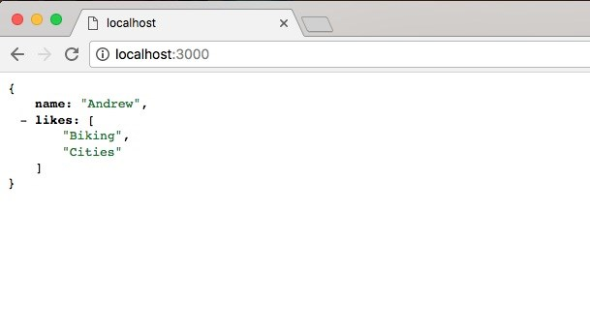

This means we can collapse the properties and quickly navigate the JSON data.

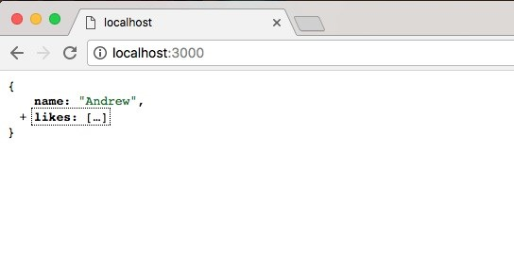

Now the only reason JSON view picked up on this is because that Content-Type header that we explored in our last request it actually changed. If I open up localhost, a lot of things look the same. But now Content-Type has an application/json Content-Type:

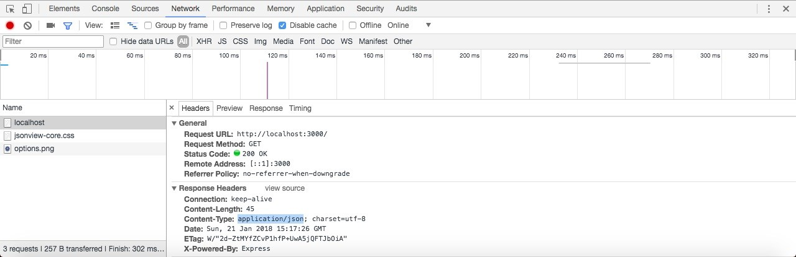

This Content-Type tells the requester whether it's an Android phone, an iOS device, or the browser that JSON data is coming back, and it should parse it as such. That's exactly what the browser does in this case.

Express also makes it really easy to set up other routes aside from the root route. We can explore that inside Atom by calling app.get a second time. We'll call app.get. We'll create a second route. We'll call this one about:

app.get('/about') app.listen(3000);

Notice that we just used /about as the route. It's important to keep that forward slash in place, but after that you can type whatever you like. In this case we'll have a /about page that someone can visit. Then I'll provide the handler. The handler will take the req and the res object:

app.get('/about', (req, res) => {

}); app.listen(3000);

This will let us figure out what kind of request came in, and it will let us respond to that request. For now just to illustrate we can create more pages, we'll keep the response simple, res.send. Inside the string we're going to print About Page:

app.get('/about', (req, res) => { res.send('About Page');

});

Now when we save the server.js file, the server is going to restart. In the browser we can visit localhost:3000/about. At /about we should now see our new data, and that's exactly what we get back, About Page shows up as shown here:

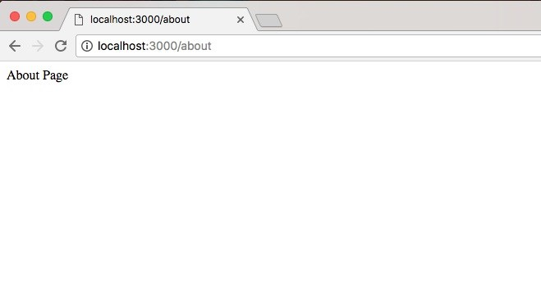

Using app.get we're able to specify as many routes as we like. For now we just have an about route and a / route, which is also referred to as the root route. The root route returns some data, which happens to be JSON, and the about route returns a little bit of HTML. Now that we have this in place and we have a very basic understanding about how we can set up routes in Express, we'd like you to create a new route /bad. This is going to simulate what happens when a request fails.

**Error handling in the JSON request**

To show the error handling request with JSON, we're going to call app.get. This app.get is going to let us register another handler for a get HTTP request. In our case the route we're looking for inside of quotes is going to be /bad. When someone makes a request for this page, what we want to do is going to be specified in the callback. The callback will take our two arguments, req and res. We'll use an arrow function (=>), which I've used for all of the handlers so far:

app.get('/bad', (req, res) => {

}); app.listen(3000);

Inside the arrow function (=>), we'll send back some JSON by calling res.send. But instead of passing in a string, or some string HTML, we'll pass in an object:

app.get('/bad', (req, res) => { res.send({

});

});

Now that we have our object in place we can specify the properties we want to send back. In this case we'll set one errorMessage. We'll set my error message property equal to a string, Unable to handle request:

app.get('/bad', (req, res) => { res.send({ errorMessage: 'Unable to handle request'

});

});

Next up we'll save the file, restarting it in nodemon, and visit it in the browser. Make sure our error message showed up correctly. In the browser, we'll visit /bad, hit *enter*, and this is what we get:

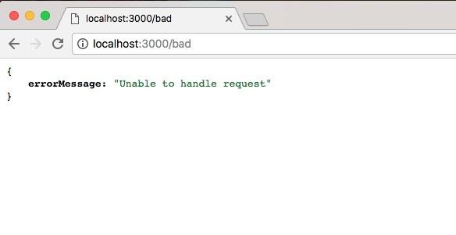

We get our JSON showing up using JSON view. We have our error message, and we have the message showing up: Unable to handle request. Now if you are using JSON view and you want to view the raw JSON data, you can actually click on View source, and it will show it in a new tab. Here, we're looking at the raw JSON data, where everything is wrapped in those double quotes:

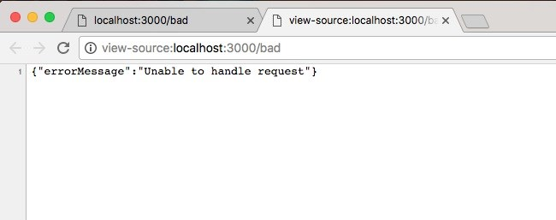

I'll stick to the JSON view data because it's a lot easier to navigate and view. We now have a very basic Express application up and running. It listens on port 3000 and it currently has handlers for 3 URLs: when we get the root of the page, when we get /about, and when we make a get request for /bad.

**The static server**

In this section, we'll learn how to set up a static directory. So if we have a website with HTML, CSS, JavaScript, and images, we can serve that up without needing to provide a custom route for every single file, which would be a real burden. Now setting this up is really simple. But before we make any updates to server.js, we'd create some static assets inside of our project that we can actually serve up.

**Making an HTML page**

In this case we'll make one HTML page that we'll be able to view in the browser. Before we get started, we do need to create a new directory, and everything inside this directory will be accessible via the web server, so it's important to not put anything in here that you don't want prying eyes to see.

Everything in the directory should be intended to be view able by anybody. We'll create a public folder to store all of our static assets, and inside here we'll make an HTML page. We'll create a help page for our example project by creating a file called help.html:

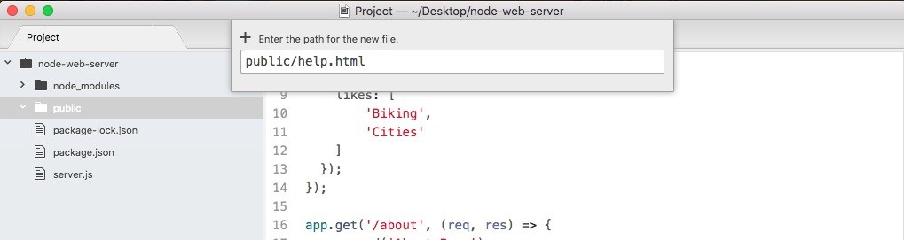

Now in help.html we will make a quick basic HTML file, although we'll not touch on all of the subtleties of HTML, since this is not really an HTML book. Instead, we'll just set up a basic page.

The first thing we need to do is create a DOCTYPE which lets the browser know what version of HTML we're using. That will look something like this:

<!DOCTYPE html>

After the opening tag, and the exclamation mark, we'd type DOCTYPE in uppercase. Then, we provide the actual DOCTYPE for HTML5, the latest version. Then we can use the greater than sign to close things up. In the next line, we'll open up our html tag so we can define our entire HTML file:

<!DOCTYPE html>

<html>

</html>

Inside html, there are two tags we'll use: the head tag which lets us configure our doc, and the body tag which contains everything we want to render to the screen.

**The head tag**

We'll create the head tag first:

<!DOCTYPE html>

<html>

<head>

</head>

</html>

Inside head, we'll provide two pieces of info, charset and title tag:

First up we have to set up the charset which lets the browser know how to render our characters.

Next up we'll provide the title tag. The title tag lets the browser know what to render in that title bar, where the new tab usually is.

As shown in the following code snippet, we'll set meta. And on meta, we'll set the charset property using equals, and provide the value utf-8:

<head>

<meta charset="utf-8">

</head>

For the title tag, we can set it to whatever we like; Help Page seems appropriate:

<head>

<meta charset="utf-8">

<title>Help Page</title>

</head>

**The body tag**

Now that our head is configured, we can add something to the body of our website. This is the stuff that's actually going to be viewable inside the viewport. Next to the head, we'll open and close the body tag:

<body>

</body>

Inside body again, we'll provide two things: an h1 title and a p paragraph tag.

The title is going to match the title tag we used in the head, Help Page, and the paragraph will just have some filler text—Some text here:

<!DOCTYPE html>

<html>

<head>

<meta charset="utf-8">

<title>Help Page</title>

</head>

<body>

<h1>Help Page</h1>

<p>Some text here</p>

</body>

</html>

Now we have an HTML page and the goal is to be able to serve this page up in our Express app without having to manually configure it.

**Serving the HTML page in the Express app**

We'll serve our HTML page in the Express app using a piece of Express middleware. Middleware lets us configure how our Express application works, and it's something we'll use extensively throughout the book. For now, we can think of it kind of like a third-party add-on.

In order to add some middleware, we'll call app.use. The app.use takes the middleware function we want to use. In our case, we'll use a built-in piece of middleware. So inside server.js, next to the variable app statement, we'll provide the function off of the express object:

const express = require('express'); var app = express(); app.use();

We will be making our own middleware in the next chapter, so it'll become clear exactly what's getting passed into use in a little bit. For now, we'll pass in express.static and to call it as a function:

var app = express(); app.use(express.static());

Now express.static takes the absolute path to the folder you want to serve up. If we want to be able to serve up /help, we'll need to provide the path to the public folder. This means we need to specify the path from the root of our hard drive, which can be tricky because your projects move around. Luckily we have the __dirname variable: app.use(express.static(__dirname));

This is the variable that gets passed into our file by the wrapper function we explored. The __dirname variable stores the path to your projects directory. In this case, it stores the path to node-web-server. All we have to do is concatenate /public to tell it to use this directory for our server. We'll concatenate using the plus sign

and the string, /public: app.use(express.static(__dirname + '/public'));

With this in place, we are now done. We have our server set up and there's nothing else to do. Now we should be able to restart our server and access /help.html. We should now see the HTML page we have. In the Terminal we can now start the app using nodemon server.js:

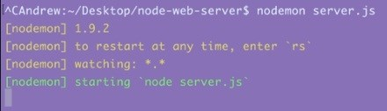

Once the app is up and running we can visit it in the browser. We'll start by going to localhost:3000:

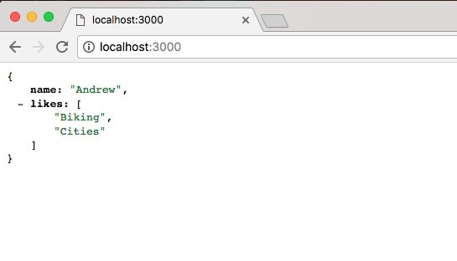

Here we get our JSON data, which is exactly what we expect. And if we change that URL to /help.html we should get our Help Page rendering:

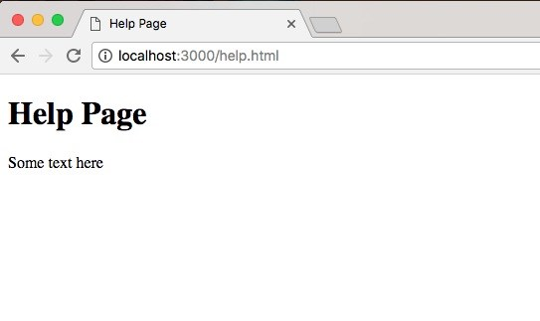

And that is exactly what we get, we have our Help Page showing to the screen. We have the Help Page title as the head, and the Some text here paragraph following as body. Being able to set up a static directory that easily has made Node the go-to choice for simple projects that don't really require a backend. If you want to create a Node app for the sole purpose of serving up a directory you can do it in about four lines of code: the first three lines and the last line in the server.js file.

**The call to app.listen**

Now one more thing we'd discuss is the call to app.listen(3000). The app.listen does take a second argument. It's optional. It's a function. This will let us do something once the server is up because it can take a little bit of time to get started. In our case we'll assign console.log a message: Server is up on port 3000:

app.listen(3000, () => { console.log('Server is up on port 3000'); });

Now it's really clear to the person who started the app that the server is actually ready to go because the message will print to the screen. If we save server.js, and go back into the Terminal we can see Server is up on port 3000 prints:



Back inside the browser we can refresh and we get the exact same results:

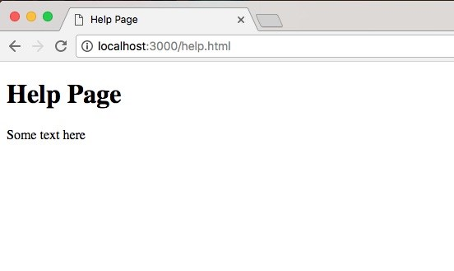

That's it for this section. We now have a static directory where we can include JavaScript, CSS, images, or any other file types we like.

**Rendering templates**

In the last couple sections, we looked at multiple ways that we can render HTML using Express. We passed some HTML into response.send, but obviously that was not ideal. It's a real pain to write the markup in a string. We also created a public directory where we can have our static HTML files, such as our help file, and we can serve these up to the browser. Both of those work great but there is a third solution, and that will be the topic in this section. The solution is a templating engine.

A templating engine will let you render HTML but do it in a dynamic way, where we can inject values, such as a username or the current date, inside the template, kind of like we would in Ruby or PHP. Using this templating engine, we'll also be able to create reusable markup for things such as a header or a footer, which is going to be the same on a lot of your pages. This templating engine, handlebars, will be the topic of this section and the next, so let's get started.

**Installing the hbs module**

The first thing we'll do is install the hbs module. This is a handlebars view engine for Express. Now there are a ton of other view engines for Express, for example EJS or Pug. We'll go with handlebars because its syntax is great. It's a great way to get started.

[Now we'll see a few things inside of the browser. First up we will visit handlebarsj s.com. This is the documentation for handlebars. It shows you exactly how to use](http://handlebarsjs.com/) all of its features, so if we want to use anything, we can always go here to learn how to use it.

Now we'll install a module that's a wrapper around handlebars. It will let us use it as an Express view engine. To view this, we'll go to [npmjs.com/package/hbs](https://www.npmjs.com/package/hbs).

*This is the URL structure for all packages. So if you ever want to find a packages page, you simply type npmjs.com/package/ the package name.*

This module is pretty popular. It's a really great view engine. They have a lot of documentation. I just want to let you know this exists as well. Now we can install and integrate it into our application. In the Terminal, we'll install hbs using npm install, the module name is hbs, and the most recent version is @4.0.1. I will use the save flag to update package.json:

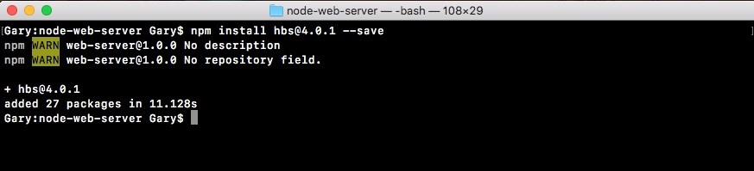

Now actually configuring Express to use this handlebars view engine is super simple. All we have to do is import it and add one statement to our Express configuration. We'll do just that inside Atom.

**Configuring handlebars**

Inside Atom, let's get started by loading in handlebars const hbs = require hbs, as shown and from here we can add that one line:

const express = require('express'); const hbs = require('hbs');

Next, let's call app.set where we call app.use for Express static:

app.set app.use(express.static(__dirname + '/public'));

This lets us set some various Express-related configurations. There's a lot of built-in ones. We'll be talking about more of them later. For now, about what we'll do is pass in a key-value pair, where the key is the thing you want to set and the value is the value you want to use. In this case, the key we're setting is view engine. This will tell Express what view engine we'd like to use and we'll pass in inside of quotes hbs:

app.set('view engine', 'hbs'); app.use(express.static(__dirname + '/public'));

This is all we need to do to get started.

**Our first template**

Now in order to create our very first template, what we'd like to do is make a directory in the project called views. The views is the default directory that Express uses for your templates. So what we'll do is add the views directory and then we'll add a template inside it. We'll make a template for our About Page.

Inside views, we'll add a new file and the file name will be about.hbs. The hbs handlebars extension is important. Make sure to include it.

Now Atom already knows how to parse hbs files. At the bottom of the about.hbs file, where it shows the current language it's using, HTML in parentheses mustache.

*Mustache is used as the name for this type of handlebars syntax because when you type the curly braces ({) I guess they kind of look like mustaches.*

What we'll do to get started though is take the contents of help.html and copy it directly. Let's copy this file so we don't have to rewrite that boilerplate, and we'll paste it right in the about.hbs:

<!DOCTYPE html>

<html>

<head>

<meta charset="utf-8">

<title>Help Page</title>

</head>

<body>

<h1>Help Page</h1>

<p>Some text here</p>

</body>

</html>

Now we can try to render this page. We'll change the h1 tag from help page to about page:

<body>

<h1>About Page</h1>

<p>Some text here</p>

</body>

We'll talk about how to dynamically render stuff inside this page later. Before that we'd like to just get this rendering.

**Getting the static page for rendering**

Inside server.js, we already have a root for /about, which means we can render our hbs template instead of sending back this about page string. We will remove our call to res.send and we'll replace it with res.render:

app.get('/about', (req, res) => { res.render });

Render will let us render any of the templates we have set up with our current view engine about.hbs file. We do indeed have the about template and we can pass that name, about.hbs, in as the first and only argument. We'll render about.hbs:

app.get('/about', (req, res) => { res.render('about.hbs');

});

This will be enough to get that static page rendering. We'll save server.js and in the Terminal, we'll clear the output and we'll run our server using nodemon

server.js:

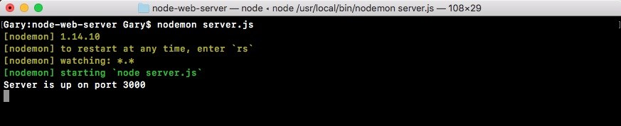

Once the server is up and running, it is showing on port 3000. We can open up this /about URL and see what we get. We'll head into Chrome and open up localhost:3000 /about, and when we do that, we get the following:

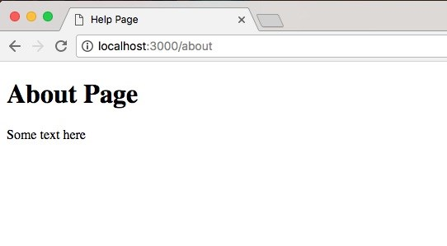

We get my about page rendered just like we'd expect it. We've got an h1 tag, which shows up nice and big, and we have our paragraph tag, which shows up the following. So far we have used hbs but we haven't actually used any of its features. Right now, we're rendering a dynamic page, so we might as well have not even included it. What I want to do is talk about how we can inject data inside of our templates.

**Injecting data inside of templates**

Let's come up with some things that we want to make dynamic inside our handlebars file. First up, we'll make this h1 tag dynamic so the page name gets passed into the template in about.hbs page, and we'll also add a footer. For now, we'll just make that a simple footer tag:

<footer>

</footer>

</body>

</html>

Inside of the footer, we'll add a paragraph and that paragraph will have the copyright for our website. We'll just say something like copyright followed by the year, which is 2018:

<footer>

<p>Copyright 2018</p>

</footer>

Now year should also be dynamic, so that as the years change, we don't have to manually update our markup. We'll look at how to make both the 2018 and the about page dynamic, which means they're getting passed in instead of being typed in the handlebars file.

In order to do this, we'll have to do two things:

We'll have to pass some data into the template. This will be an object a set of key value pairs, and

We'll have to learn how to pull off some of those key-value pairs inside of our handlebars file

Passing in data is pretty simple. All we have to do is specify a second argument to res.render in server.js. This will take an object, and on this object we can specify whatever we like. We might have a pageTitle that gets set equal to About Page:

app.get('/about', (req, res) => { res.render('about.hbs', { pageTitle: 'About Page'

});

});

We have one piece of data getting injected in the template. It's not used yet but it is indeed getting injected. We could also add another one like currentYear. We'll put currentYear next to the pageTitle and we'll set currentYear equal to the actual year off of the date JavaScript constructor. This will look something like this:

app.get('/about', (req, res) => { res.render('about.hbs', { pageTitle: 'About Page',

currentYear: new Date().getFullYear()

});

});

We'll create a new date which makes a new instance of the date object. Then, we'll use a method called getFullYear, which returns the year. In this case, it would return 2018, just like this .getFullYear. Now we have a pageTitle and a currentYear. These are both getting passed in, and we can use them.

In order to use these pieces of data, what we have to do inside of our template is use that handlebars syntax which looks a little bit like shown in the following code. We start by opening up two curly braces in the h1 tag, then we close two curly braces. Inside the curly braces, we can reference any of the props we passed in. In this case, let's use pageTitle, and inside our copyright paragraph, we'll use, inside of double curly braces, currentYear:

<body>

<h1>{{pageTitle}}</h1> <p>Some text here</p>

<footer>

<p>Copyright 2018</p>

</footer>

</body>

</html>

With this in place, we now have two pieces of dynamic data getting injected inside our application. Now nodemon should have restarted in the background, so there's no need to manually do anything there. When we refresh the page, we do still get About Page, which is great:

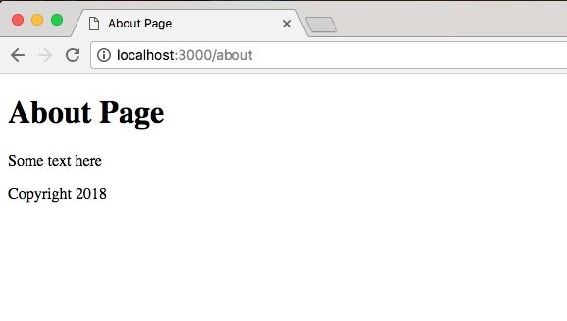

This comes from the data we defined in server.js, and we get Copyright 2018 showing up. Well this web page is pretty simple and doesn't look that interesting. At least you know how to create those servers and inject that data inside your web page. All you have to do from here is add some custom styles to get things looking nice.

Before we go ahead, let's move into the about file and swap out the title. Currently, it says Help Page. That's left over from the public folder. Let's change it to Some Website:

<!DOCTYPE html>

<html>

<head>

<meta charset="utf-8">

<title>Some Website</title>

</head>

<body>

<h1>{{pageTitle}}</h1> <p>Some text here</p>

<footer>

<p>Copyright 2018</p>

</footer>

</body>

</html>

Now that we have this in place. Next, we'll create a brand new template and that template is going to get rendered when someone visits the root of our website, the / route. Now currently, we render some JSON data:

app.get('/', (req, res) => {

// res.send('<h1>Hello Express!</h1>'); res.send({ name: 'Andrew', likes: [ 'Biking',

'Cities'

]

});

What we want to do is replace this with a call to response.render, rendering a brand new view.

**Rendering the template for the root of the website**

To get started, we'll duplicate the about.hbs file so we can start customizing it for our needs. We'll duplicate it, and call this one home.hbs:

<!DOCTYPE html>

<html>

<head>

<meta charset="utf-8">

<title>Some Website</title>

</head>

<body>

<h1>{{pageTitle}}</h1> <p>Some text here</p>

<footer>

<p>Copyright 2018</p>

</footer>

</body>

</html>

Now from here most things are going to stay the same. We'll keep the pageTitle in place. We'll also keep the Copyright and footer following. What we want to change though is this paragraph. It was fine that the About Page as a static one, but for the home page, we'll set it equal to, inside curly braces, the welcomeMessage property:

<body>

<h1>{{pageTitle}}</h1>

<p>{{welcomeMessage}}</p>

<footer>

<p>Copyright {{currentYear}}</p>

</footer>

</body>

Now welcomeMessage is only going to be available on home.hbs, which is why we have specifying it in home.hbs but not in about.hbs.

Next up, we needed to call response render inside of the callback. This will let us actually render the page. We'll add response.render, passing in the template name we want to render. This one is called home.hbs. Then we'll pass in our data:

app.get('/', (req, res) => { res.render('home.hbs', { })

});

Now to get started, we can pass in the page title. We'll set this equal to Home Page and we'll pass in some sort of generic welcome message - Welcome to my website. Then we'll pass in the currentYear, and we already know how to fetch the currentYear: new Date(), and on the date object, we'll call the getFullYear method:

res.render('home.hbs', { pageTitle: 'Home Page', welcomeMessage: 'Welcome to my website', currentYear: new Date().getFullYear()

})

With this in place, all we needed to do is save the file, which is automatically going to restart the server using nodemon and refresh the browser. When we do that, we get the following:

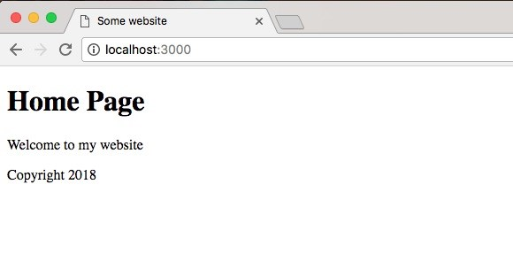

We get our Home Page title, our Welcome to my website message, and my copyright with the year 2018. And if we go to /about, everything still looks great. We have our dynamic page title and copyright and we have our static some text here text:

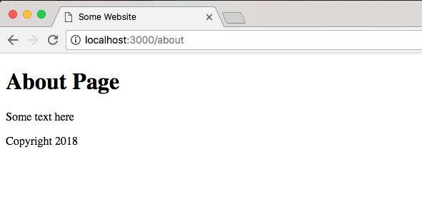

With this in place, we are now done with the very basics of handlebars. We see how this can be useful inside of a real-world web app. Aside from a realistic example such as the copyright, other reasons you might use this is to inject some sort of dynamic user data - things such as a username and email or anything else.

Now that we have a basic understanding about how to use handlebars to create static pages, we'll look at some more advanced features of hbs inside the next section.

**Advanced templates**

In this section, we'll learn a few more advanced features that handlebars has to offer. This will make it easier to render our markup, especially markup that's used in multiple places, and it will make it easier to inject dynamic data into your web pages.

In order to illustrate the first thing we'll talk about, I want to open up both about.hbs and home.hbs, and you'll notice down at the bottom that they both have the exact same footer code as follows:

<footer>

<p>Copyright {{currentYear}}</p>

</footer>

We have a little copyright message for both and they both have the same header area, which is the h1 tag.

Now this really isn't a problem because we have two pages, but as you add more and more pages it's going to become a real pain to update your header and your footer. You'll have to go into every file and manage the code there, but what we'll talk about instead is something called a partial.

**Adding partials**

A partial is a partial piece of your website. It's something you can reuse throughout your templates. For example, we might have a footer partial that renders the footer code. You can include that partial on any page you need a footer. You could do the same thing for header. In order to get started, the first thing we need to do is set up our server.js file just a little bit to let handlebars know that we want to add support for partials.

In order to do this, we'll add one line of code in the server.js file where we declared our view engine previously, and it will look something like this

(hbs.registerPartials):

hbs.registerPartials app.set('view engine', 'hbs'); app.use(express.static(__dirname + '/public'));

Now registerPartials is going to take the directory you want to use for all of your handlebar partial files, and we'll be specifying that directory as the first and only argument. Once again, this does need to be the absolute directory, so I'll use the __dirname variable: hbs.registerPartials(__dirname)

Then we can concatenate the rest of the path, which will be /views. In this case, I want you to use /partials. hbs.registerPartials(__dirname + '/views/partials')

We'll store our partial files right inside a directory in the views folder. Now we can create that folder right in views called partials.

Inside partials, we can put any of the handlebars partials we like. To illustrate how they work, we'll create a file called footer.hbs:

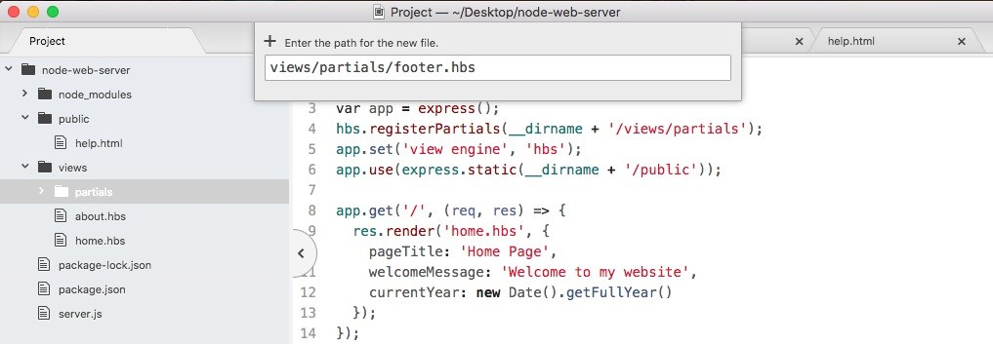

Inside footer.hbs, we'll have access to the same handlebars features, which means we can write some markup, we can inject variables, we can do whatever we like. For now, what we'll do is copy the footer tag exactly, pasting it inside footer.hbs:

<footer>

<p>Copyright {{getCurrentYear}}</p>

</footer>

Now we have our footer.hbs file, this is the partial and we can include it in both about.hbs and home.hbs. In order to do that, we'll delete the code that we already have in the partial and we'll replace it with opening and closing two curly braces. Now instead of injecting data, we want to inject a template and the syntax for that is to add a greater than symbol with a space, followed by the partial name. In our case that partial is called footer, so we can add this right here:

{{> footer}}

</body>

</html>

Then I can save about and do the same thing over in home.hbs. We now have our footer partial. It's rendering on both pages.

**Working of partial**

To illustrate how this works, I'll fire up my server and by default nodemon; it's not going to watch your handlebars files. So if you make a change, the website's not going to render as you might expect. We can fix this by running nodemon, passing in server.js and providing the -e flag. This lets us specify all of the extensions we want to watch. In our case, we'll watch the JS extension for the server file, and after the comma, the hds extension:

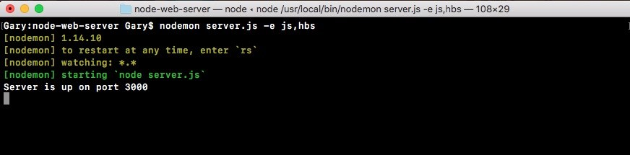

Now our app is up and running, we can refresh things over in the browser, and they should look the same. We have our about page with our footer:

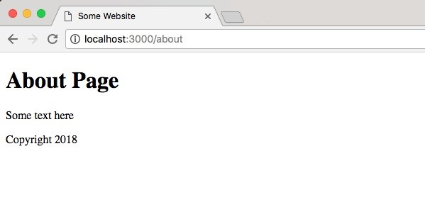

We have our home page with the exact same footer:

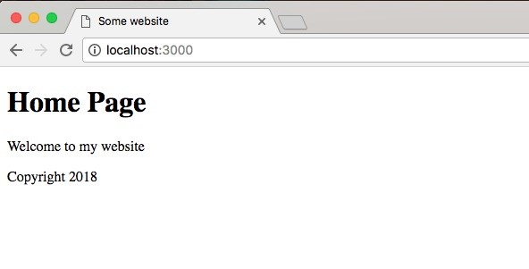

The advantage now is if we want to change that footer, we just do it in one place, in the footer.hbs file.

We can add something to our footer paragraph tag. Let's add a little message created by Andrew Mead with a -:

<footer>

<p>Created By Andrew Mead - Copyright {{CurrentYear}}</p> </footer>

Now, save the file and when we refresh the browser, we have our brand new footer for Home Page:

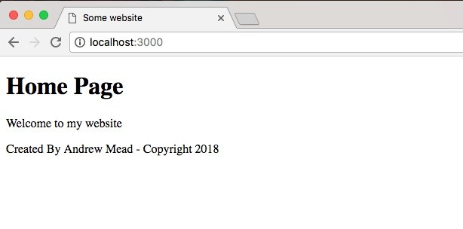

We have our brand new footer for About Page:

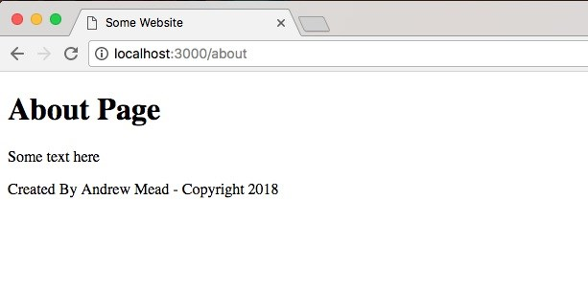

It will show up for both the home page and the about page. There's no need to do you anything manual in either of these pages, and this is the real power of partials. You have some code, you want to reuse it inside your website, so you simply create a partial and you inject it wherever you like.

**The Header partial**

Now that we have the footer partial in place, let's create the header partial. That means we'll need to create a brand new file header.hbs. We'll want to add the h1 tag inside that file and then we'll render the partial in both about.hbs and home.hbs. Both pages should still look the same.

We'll get started by creating a new file in the partials folder called header.hbs.

Inside header.hbs, we'll take the h1 tag from our website, paste it right inside and save it:

<h1>{{pageTitle}}</h1>

Now we can use this header partial in both about and home files. Inside of about, we need to do this using the syntax, the double curly braces with the greater than sign, followed by the partial name header. We'll do the exact same thing for the home page. In the home page, we'll delete our h1 tag, inject the header and save the file:

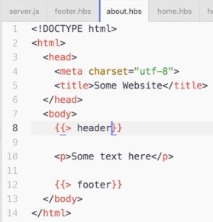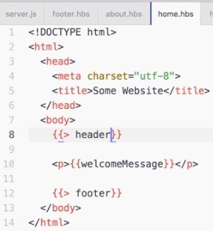

Now we'd create something slightly different just so we can test that it actually is using the partial. We'll type 123 right after the h1 tag in header.hbs:

<h1>{{pageTitle}}</h1>123

Now that all the files are saved, we should be able to refresh the browser, and we see about page with 123 printing, which is fantastic:

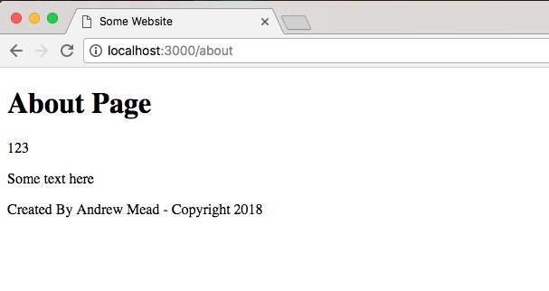

This means the header partial is indeed working, and if I go back to the home page, everything still looks great:

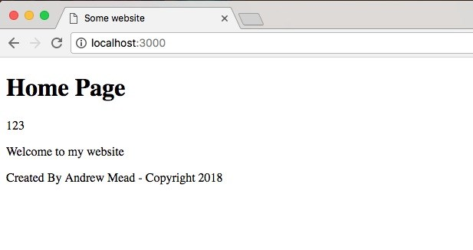

Now that we have the header broken out into its own file, we can do all sorts of things. We can take our h1 tag and put it inside of a header tag, which is the appropriate way to declare your header inside of HTML. As shown, we add an opening and closing header tag. We can take the h1 and we can move it right inside:

<header>

<h1>{{pageTitle}}</h1>

</header>

We could also add some links to the other pages on our website. We could add an anchor tag for the homepage by adding an a tag:

<header>

<h1>{{pageTitle}}</h1>

<p><a></a></p>

</header>

Inside the a tag, we'll specify the link text we'd like to show up. I'll go with Home, then inside the href attribute, we can specify the path the link should take you to, which would just be /:

<header>

<h1>{{pageTitle}}</h1>

<p><a href="/">Home</a></p>

</header>

Then we can take the same paragraph tag, copy it and paste it in the next line and make a link for the about page. I'll change the page text to About, the link text, and the URL instead of going to / will go to /about:

<header>

<h1>{{pageTitle}}</h1>

<p><a href="/">Home</a></p>

<p><a href="/about">About</a></p>

</header>

Now we've made a change to our header file and it will be available on all of the pages of our website. I'm on the home page. If I refresh it, I get Home and About page links:

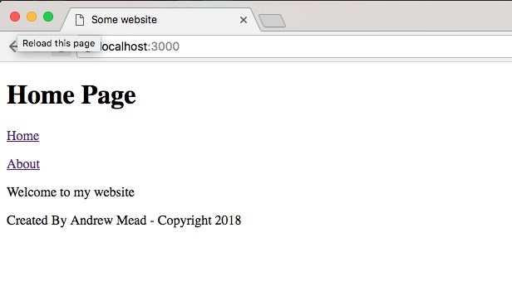

I can click on the About to go to the About Page:

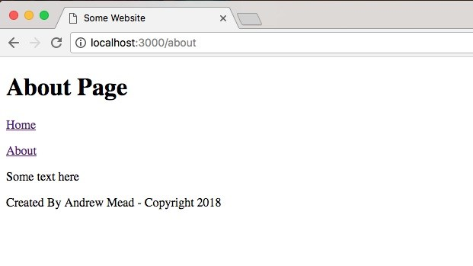

Similarly, I can click on Home to come right back. All of this is much easier to manage now that we have partials inside of our website.

**The Handlebars helper**

Now before we go further, there is one more thing I want to talk about, that is, a handlebars helper. Handlebars helpers are going to be ways for us to register functions to run to dynamically create some output. For example, inside server.js, we currently inject the current year inside of both of our app.get templates and that's not really necessary.

There is a better way to pass this data in, and this data shouldn't need to be provided because we'll always use the exact same function. We'll always take the new date getfullYear return value passing it in. Instead, we'll use a partial, and we'll set ours up right now. Now a partial is nothing more than a function you can run from inside of your handlebars templates.

All we need to do is register it and I'll do that in the server.js, following on from where we set up our Express middleware. As shown in the following code, we'll call hbs.register and we'll be registering a helper, so we'll call a registerHelper:

hbs.registerPartials(__dirname + '/views/partials') app.set('view engine', 'hbs');

app.use(express.static(__dirname + '/public')); hbs.registerHelper();

Now registerHelper takes two arguments:

The name of the helper as the first argument The function to run as the second argument.

The first argument right here will be getCurrentYear in our case. We'll create a helper that returns that current year: hbs.registerHelper('getCurrentYear',);

The second argument will be our function. I'll use an arrow function (=>):

hbs.registerHelper('getCurrentYear', () => {

});

Anything we return from this function will get rendered in place of the getCurrentYear call. That means if we call getCurrentYear inside the footer, it will return the year from the function, and that data is what will get rendered.

In the server.js, we can return the year by using return and having the exact same code we have app.get object:

hbs.registerHelper('getCurrentYear'), () => { return new Date().getFullYear()

});

We'll make a new date and we'll call its getFullYear method. Now that we have a helper, we can remove this data from every single one of our rendering calls:

hbs.registerHelper('getCurrentYear, () => { return new Date().getFullYear()

});

app.get('/', (req, res) => { res.render('home.hbs', { pageTitle: 'Home Page', welcomeMessage: 'Welcome to my website'

}); });

app.get('/about', (req, res) => { res.render('about.hbs', { pageTitle: 'About Page'

});

});

This is going to be really fantastic because there really is no need to compute it for every page since it's always the same. Now that we've removed that data from the individual calls to render, we will have to use getCurrentYear inside the footer.hbs file:

<footer>

<p>Created By Andrew Mead - Copyright {{getCurrentYear}}</p> </footer>

Instead referencing the current year, we will use the helper getCurrentYear, and there's no need for any special syntax. When you use something inside curly braces that clearly isn't a partial, handlebars is first going to look for a helper with that name. If there is no helper, it'll look for a piece of data with that getCurrentYear name.

In this case, it will find the helper, so everything will work as expected. We can now save footer.hbs, move into the browser, and give things a refresh. When I refresh the page, we still get Copyright 2018 in Home Page:

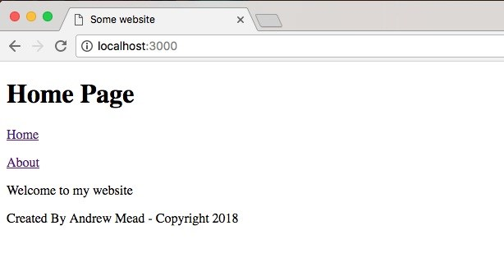

If I go to the About Page, everything looks great:

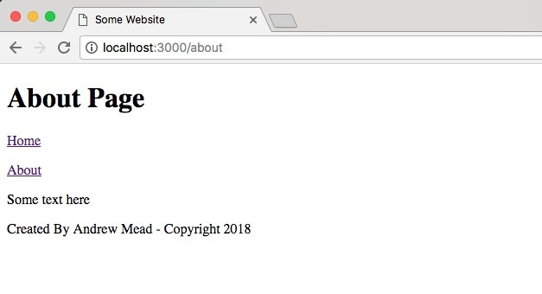

We can prove that data is coming back from our helper by simply returning something else. Let's comment out our helper code in server.js and before the comment, we can use return test, just like this:

hbs.registerHelper('getCurrentYear', () => { return 'test';//return new Date().getFullYear() });

We can now save server.js, refresh the browser, and we get tests showing up as shown here:

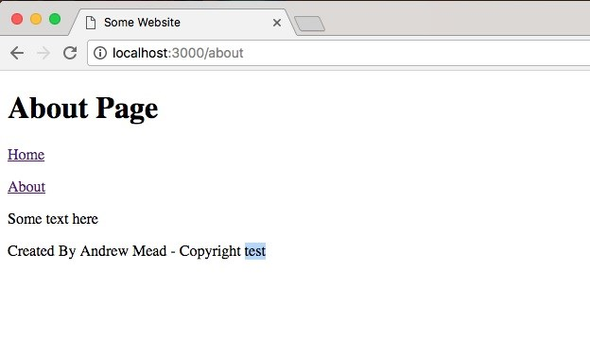

So the data that renders right after the Copyright word is indeed coming from that helper. Now we can remove the code so we return the proper year.

**Arguments in Helper**

Helpers can also take arguments, and this is really useful. Let's create a second helper that's going to be a capitalization helper. We'll call the helper screamIt and its job will be to take some text and it will return that text in uppercase.

In order to do this, we will be calling hbs.registerHelper again. This helper will be called screamIt, and it will take a function because we do need to run some code in order to do anything useful:

hbs.registerHelper('getCurrentYear', () => { return new Date().getFullYear()

}); hbs.registerHelper('screamIt', () => {

});

Now screamIt is going to take text to scream and all it will do is call on that string the toUpperCase method. We'll return text.toUpperCase, just like this:

hbs.registerHelper('screamIt', (text) => { return text.toUpperCase();

});

Now we can actually use screamIt in one of our files. Let's move into home.hbs. Here, we have our welcome message in the p tag. We'll remove it and we'll scream the welcome message. In order to pass data into one of our helpers, we first have to reference the helper by name, screamIt, then after a space we can specify whatever data we want to pass in as arguments.

In this case, we'll pass in the welcome message, but we could also pass in two arguments by typing a space and passing in some other variable which we don't have access to:

<!DOCTYPE html>

<html>

<head>

<meta charset="utf-8">

<title>Some Website</title>

</head>

<body>

{{> header}}

<p>{{screamIt welcomeMessage}}</p>

{{> footer}}

</body>

</html>

For now, we'll use it like this, which means we'll call the screamIt helper, passing in one argument welcomeMessage. Now we can save home.hbs, move back into the browser, go to the Home Page and as shown following, we get WELCOME TO MY WEBSITE in all uppercase:

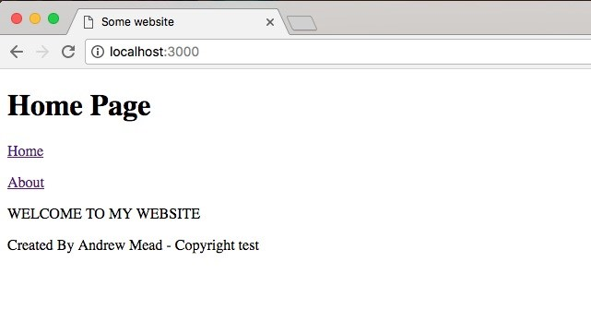

Using handlebars helpers, we can create both functions that don't take arguments and functions that do take arguments. So when you need to do something to the data inside of your web page, you can do that with JavaScript. Now that we have this in place, we are done.

**Express Middleware**

In this section, you'll learn how to use Express middleware. Express middleware is a fantastic tool. It allows you to add on to the existing functionality that Express has. So if Express doesn't do something you'd like it to do, you can add some middleware and teach it how to do that thing. Now we've already used a little bit of middleware. In server.js file, we used some middleware and we teach Express how to read from a static directory, which is shown here: app.use(express.static(__dirname + '/public'));

We called app.use, which is how you register middleware, and then we provided the middleware function we want to use.

Now middleware can do anything. You could just execute some code such as logging something to the screen. You could make a change to the request or the response object. We'll do just that in the next chapter when we add API authentication. We'll want to make sure the right header is sent. That header will be expected to have an API token. We can use middleware to determine whether or not someone's logged in. Basically, it will determine whether or not they should be able to access a specific route, and we can also use middleware to respond to a request. We could send something back from the middleware, just like we would anywhere else, using response.render or response.send.

**Exploring middleware**

In order to explore middleware, we'll create some basic middleware. Just following where we call app.use registering our Express static middleware, we'll call app.use again:

app.use(express.static(__dirname + '/public')); app.use();

Now app.use is how you register middleware, and it takes a function. So, we'll pass in an arrow function (=>):

app.use(() => {

});

The use function takes just one function. There is no need to add any other arguments. This function will get called with the request (req) object, the response (res) object and a third argument, next:

app.use((req, res, next) => {

});

Now request and response objects, these should seem familiar by now. They're the exact same arguments we get whenever we register a handler. The next argument is where things get a little trickier. The next argument exists so you can tell Express when your middleware function is done, and this is useful because you can have as much middleware as you like registered to a single Express app. For example, I have some middleware that serves up a directory. We'll write some more that logs some request data to the screen, and we could have a third piece that helps with application performance, keeping track of response times, all of that is possible.

Now inside app.use function, we can do anything we like. We might log something to the screen. We might make a database request to make sure a user is authenticated. All of that is perfectly valid and we use the next argument to tell Express when we're done. So if we do something asynchronous, the middleware is not going to move on. Only when we call next, will the application continue to run, like this:

app.use((req, res, next) => { next(); });

Now this means if your middleware doesn't call next, your handlers for each request, they're never going to fire. We can prove this. Let's call app.use, passing in an empty function:

app.use((req, res, next) => {

});

Let's save the file and in the Terminal, we'll run our app using nodemon with

server.js

:

**nodemon server.js**

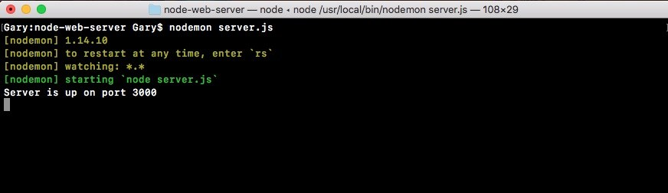

I'll move into the browser and I'll make a request for the home page. I'll refresh

the page and you can see that up top, it is trying to load but it's never going to finish:

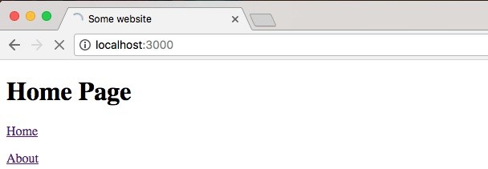

Now it's not that it can't connect to the server. It connects to the server just fine. The real problem is that inside our app, we have middleware that doesn't call next. To fix this, all we'll do is call next like this:

app.use((req, res, next) => { next(); });

Now when things refresh over inside the browser, we get our Home Page exactly as we expect it:

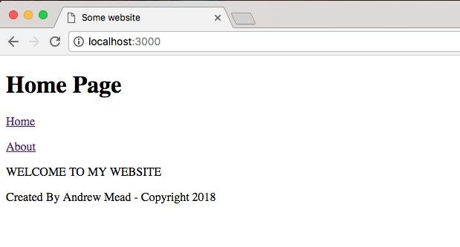

The only difference is now we have a place where we can add on some functionality.

**Creating a logger**

Inside app.use, we're going to get started by creating a logger that will log out all of the requests that come in to the server. We'll store a timestamp so we can see exactly when someone made a request for a specific URL.

To get started inside the middleware, let's get the current time. I'll make a variable called now, setting it equal to newDate, creating a new instance of our date object, and I'll call it toString method:

app.use((req, res, next) => { var now = new Date().toString(); next(); });

The toString method creates a nice formatted date, a human-readable timestamp. Now that we have our now variable in place, we can start creating the actual logger by calling console.log.

Let's call console.log, passing in whatever I like. Let's pass in inside of ticks the now variable with a colon after:

app.use((req, res, next) => { var now = new Date().toString();

console.log(`${now};`) next(); });

Now if I save my file, things are going to restart in the Terminal because nodemon is running. When we make a request for the site again and we go into the Terminal, we should see the log:



Currently it's just a timestamp, but we are on the right track. Now everything is working because we called next, so after this console.log call prints to the screen, our application continues and it serves up the page.

Inside middleware, we can add on more functionality by exploring the request object. On the request object, we have access to everything about the request— the HTTP method, the path, query parameters, and anything that comes from the client. Whether the client is an app, a browser, or an iPhone, it is all going to be available in that request object. Two things we'll pull off now are the HTTP method and the path.

[If you want to look at a full list of the things you have access to, you can go to ex pressjs.com, and go to API reference:](http://expressjs.com/)

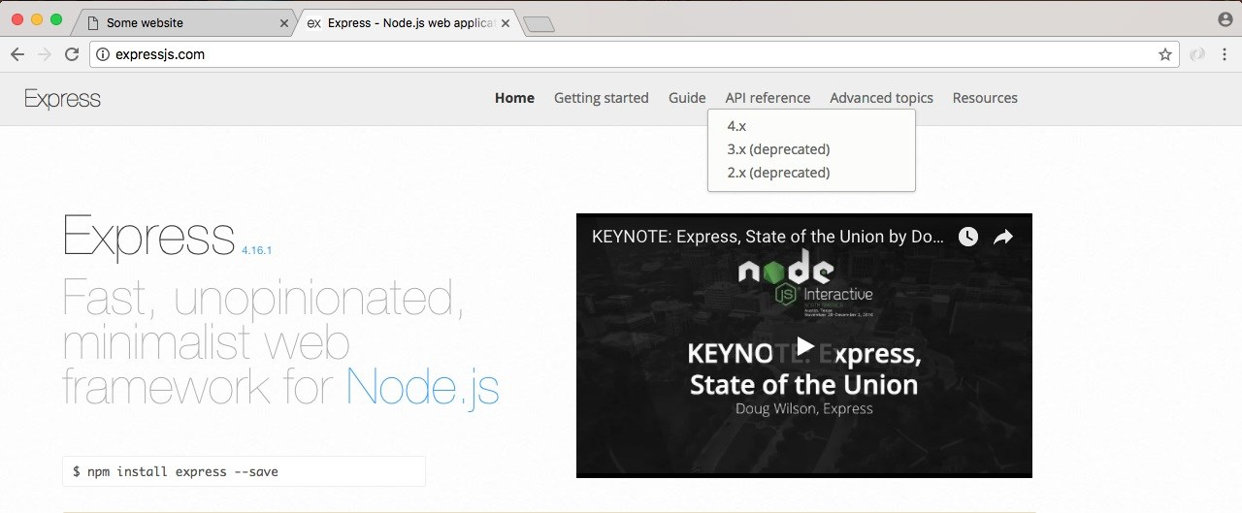

We happen to be using a 4.x version of Express, so we'll click that link:

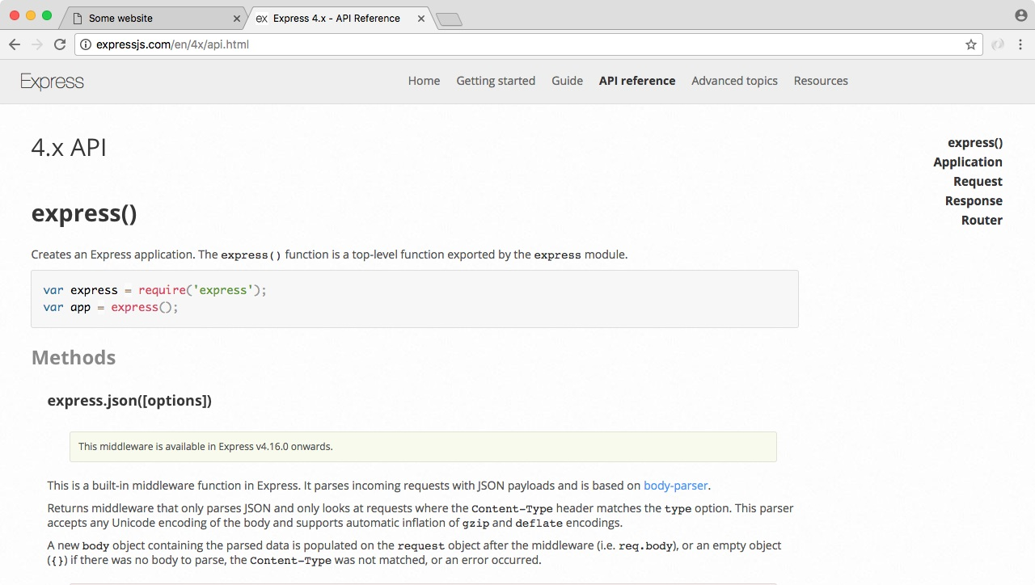

On the right-hand side of this link, we have both Request and Response. We'll look for the request objects, so we'll click that. This'll lead us to the following:

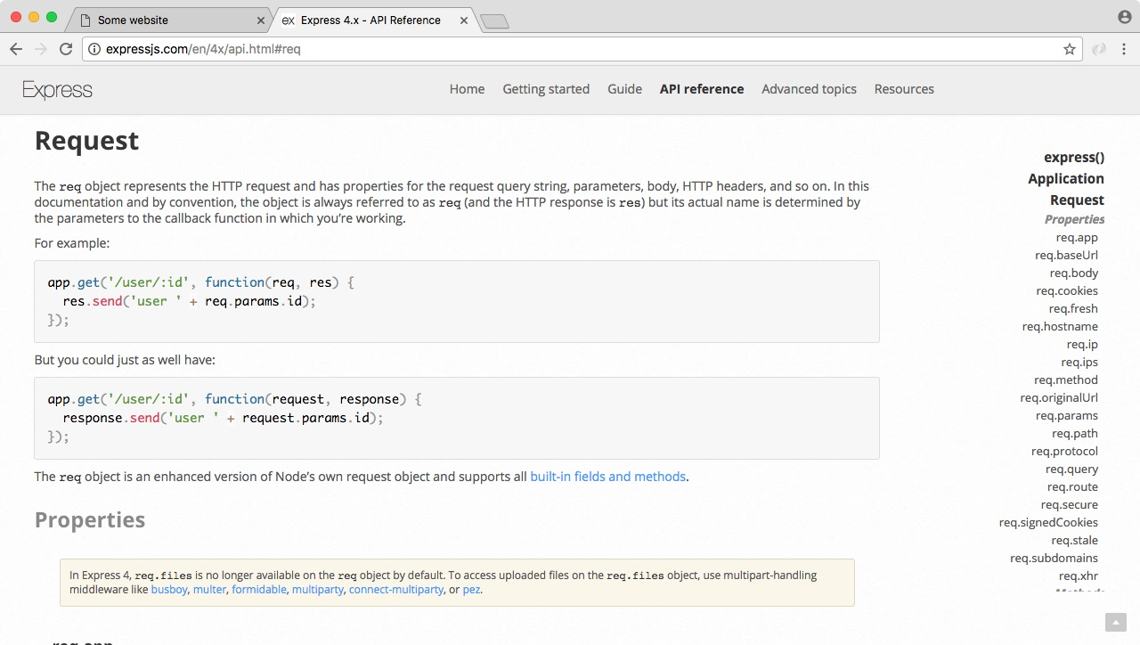

We'll be using two request properties: req.url and req.method. Inside Atom, we can start implementing those, adding them into console.log. Right after the timestamp, we'll print the HTTP method. We'll be using other methods later. For now we've only used the get method. Right inside the console.log, I'll inject request.method printing it to the console: app.use((req, res, next) => {

var now = new Date().toString();

console.log(`${now}: ${req.method}`) next(); });

Next up we can print the path so we know exactly what page the person requested. I'll do that by injecting another variable, req.url: console.log(`${now}: ${req.method} ${req.url}`);

With this in place, we now have a pretty useful piece of middleware. It takes the request object, it spits out some information and then it moves on, letting the server process that request which was added. If we save the file and rerun the app from the browser, we should be able to move into the Terminal and see this new logger printing to the screen, and as shown following we get just that:



We have our timestamp, the HTTP method which is GET, and the path. If we change the path to something more complicated, such as /about, and we move back into the Terminal, we'll see the /about where we accessed req.url:

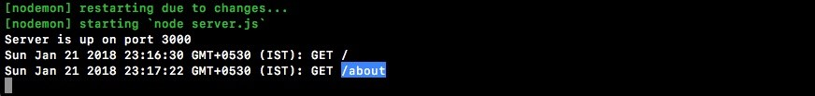

Now this is a pretty basic example of some middleware. We can take it a step further. Aside from just logging a message to the screen, we'll also print the message to a file.

**Printing message to file**

To print the message to a file, let's load in fs up in the server.js file. We'll create a constant. Call that const fs and set that equal to the return result from requiring the module:

const express = require('express'); const hbs = require('hbs'); const fs = require('fs');

Now we can implement this down following in the app.use. We'll take our template string, which is currently defined inside console.log. We'll cut it out and instead store in a variable. We'll make a variable called log, setting it equal to that template string as shown here:

app.use((req, res, next) => { var now = new Date().toString(); var log = `${now}: ${req.method} ${req.url}`;

console.log(); next(); });

Now we can pass that log variable into both console.log and into an fs method to write to our file system. For console.log, we will call log like this: console.log(log);

For fs, I'll call fs.appendFile. Now as you remember, appendFile lets you add on to a file. It takes two arguments: the file name and the thing we want to add. The file name we'll use is server.log. We'll create a nice log file and the actual contents will just be the log message. We will need to add one more thing: we also want to move on to the next line after every single request gets logged, so I'll concatenate the new line character, which will be \n: fs.appendFile('server.log', log + '\n');

*If you're using Node V7 or greater, you will need to make a small tweak to this line. As shown in the following code, we added a third argument to fs.appendFile. This is a callback function. It's now required.*

*fs.appendFile('server.log', log + '\n', (err) => { if (err) { console.log('Unable to append to server.log.')*

*}*

*});*

*If you don't have a callback function, you'll get a deprecation warning over inside the console. Now as you can see, our callback function here takes an error argument. If there is an error, we just print a message to the screen. If you change your line to look like this, regardless of your Node version, you'll be future proof. If you're on Node V7 or greater, the warning in the console will go away. Now the warning is going to say something such as deprecation warning. Calling an asynchronous function without callback is deprecated. If you see that warning, make this change.*

Now that we have this in place, we can test things out. I save the file, which should be restarting things inside of nodemon. Inside Chrome, we can give the page a refresh. If we head back into the Terminal, we do still get my log, which is great:

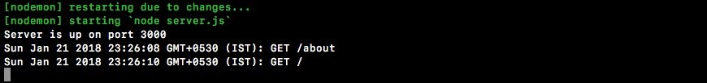

Notice we also have a request for a favicon.ico. This is usually the icon that's shown in the browser tab. I have one cached from a previous project. There actually is no icon file defined, which is totally fine. The browser still makes the request anyway, which is why that shows up as shown in the previous code snippet.

Inside Atom, we now have our server.log file, and if we open it up, we have a log of all the requests that were made:

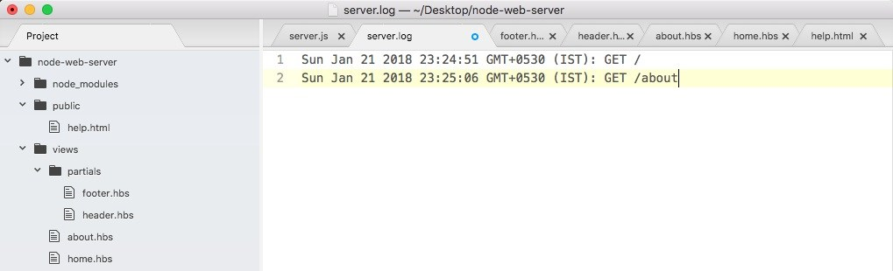

We have timestamps, HTTP methods, and paths. Using app.use, we were able to create some middleware that helps us keep track of how our server is working.

Now there are times where you might not want to call next. We learned that we could call next after we do something asynchronous, such as a read from a database, but imagine something goes wrong. You can avoid calling next to never move on to the next piece of middleware. We would like to create a new view inside the views folder. We'll call this one maintenance.hbs. This will be a handlebars template that will render when the site is in maintenance mode.

**The maintenance middleware without the next object**

We'll start with making the maintenance.hbs file by duplicating home.hbs. Inside maintenance.hbs, all we'll do is wipe the body and add a few tags:

<!DOCTYPE html>

<html>

<head>

<meta charset="utf-8">

<title>Some Website</title>

</head>

<body>

</body>

</html>

As shown in the following code, we'll add an h1 tag to print a little message to the user:

<body>

<h1></h1>

</body>

We're going to use something like We'll be right back:

<body>

<h1>We'll be right back</h1>

</body>

Next, I can add a paragraph tag:

<h1>We'll be right back</h1>



<body>

<p>

</p>

</body>

*Now we will be able to use p followed by the tab. This is a shortcut inside Atom for creating an HTML tag. It works for all tags. We could type body and hit enter or I could type p and press enter, and the tag will be created.*

Inside the paragraph, I'll leave a little message: The site is currently being updated:

<p>

The site is currently being updated.

</p>

Now that we have our template file in place, we can define our maintenance middleware. This is going to bypass all of our other handlers, where we render other files and print JSON, and instead it'll just render this template to the screen. We'll save the file, move into server.js, and define that middleware.

Right next to the previously-defined middleware, we can call app.use passing in our function. The function will take those three arguments: request (req), response (res), and next:

app.use((req, res, next) => {

})

Inside the middleware, all we'll need to do is call res.render. We'll add res.render passing in the name of the file we want to render; in this case, it's

maintenance.hbs:

app.use((req, res, next) => { res.render('maintenance.hbs');

});

That is all you needed to do to set up our main middleware. This middleware will stop everything after it from executing. We don't call next, so the actual handlers in the app.get function, they will never get executed and we can test this.

**Testing the maintenance**

**middleware**

Inside the browser, we'll refresh the page, and we will get the following output:

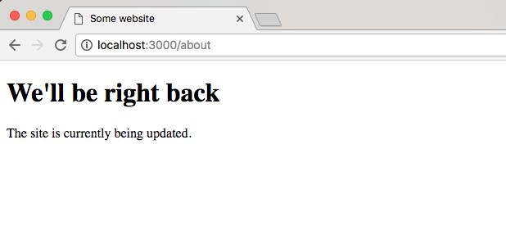

We get the maintenance page. We can go to the home page and we get the exact same thing:

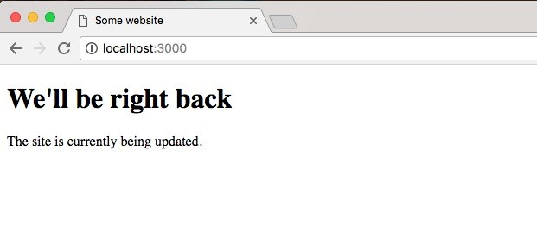

Now there's one more really important piece to middleware we haven't discussed yet. Remember inside the public folder, we have a help.html file as shown here:

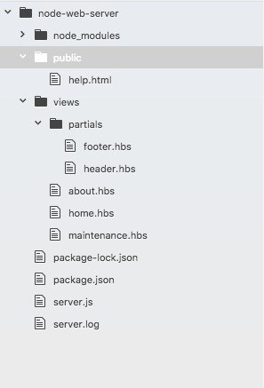

If we visit this in the browser by going to localhost:3000/help.html, we'll still get the help page. We'll not get the maintenance page:

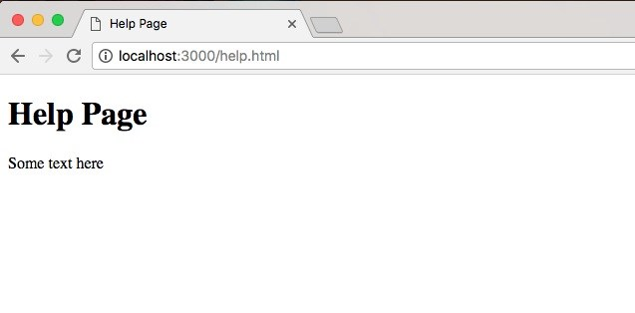

That is because middleware is executed in the order you call app.use. This means the first thing we do is we set up our Express static directory, then we set up our logger, and finally we set up our maintenance.hbs logger:

app.use(express.static(__dirname + '/public'));

app.use((req, res, next) => { var now = new Date().toString(); var log = `${now}: ${req.method} ${req.url}`;

console.log(log); fs.appendFile('server.log', log + '\n'); next();

});

app.use((req, res, next) => { res.render('maintenance.hbs');

});

This is a pretty big problem. If we also want to make the public directory files such as help.html private, we'll have to reorder our calls to app.use because currently the Express server is responding inside of the Express static middleware, so our maintenance middleware doesn't get a chance to execute.

To resolve this, we'll take the app.use Express static call, remove it from the file, and add it after we render the maintenance file to the screen. The resultant code is going to look like this:

app.use((req, res, next) => { var now = new Date().toString(); var log = `${now}: ${req.method} ${req.url}`;

console.log(log); fs.appendFile('server.log', log + '\n'); next(); });

app.use((req, res, next) => { res.render('maintenance.hbs');

}); app.use(express.static(__dirname + '/public'));

Now, everything will work as expected, no matter what we're going to log the request. Then we'll check if we're in maintenance mode if the maintenance middleware function is in place. If it is, we'll render the maintenance file. If it's not, we'll ignore it because it'll be commented out or something like that, and finally we'll be using Express static. This is going to fix all those problems. If I re-render the app now, I get the maintenance page on help.html:

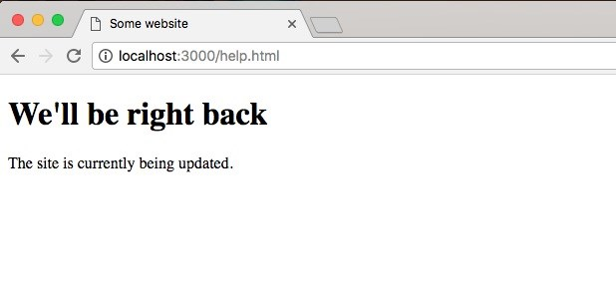

If I go back to the root of the website, I still get the maintenance page:

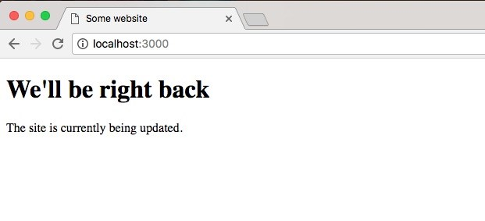

Now once we're done with the maintenance middleware, we can always comment it out. This will remove it from being executed, and the website will work as expected.

This has been a quick dive into Express middleware. We'll be using it a lot more throughout the book. We'll be using middleware to check if our API requests are actually authenticated. Inside the middleware, we'll be making a database request, checking if the user is indeed who they say they are.

**Summary**

In this chapter you learned about Express and how it can be used to easily create websites. We looked at how we can set up a static web server, so when we have an entire directory of JavaScript, images, CSS, and HTML. We can serve that up easily without needing to provide routes for everything. This will let us create all sorts of applications, which we'll be doing throughout the rest of the book.

Next, we continued on learning how to use Express. We took a look at how we can render dynamic templates, kind of like we would with a PHP or Ruby on Rails file. We have some variables and we rendered a template injecting those variables. Then we learned a little bit about handlebars partials, which let us create reusable chunks of code like headers and footers. We also learned about Handlebars helpers, which is a way to run some JavaScript code from inside of your handlebars templates. Lastly, we moved back to talking about Express and how it can customize our requests, responses, our server.

In the next chapter, we'll look into deploying applications to the web.

**Deploying Applications to Web**

In this chapter, we'll worry about adding version control and deploying our applications because when it comes to creating real-world Node apps, deploying your app to the Web is obviously a pretty big part of that. Now in the real world, every single company uses some form of version control. It is essential to the software development process, and most of them aren't using Git. Git has become really popular, dominating the market share for version control. Git is also free and open source, and there is a ton of great educational material. They have a book on how to learn Git. It's free and Stack Overflow is filled with Gitspecific questions and answers.

We'll be using Git to save our project. We'll also be using it to back up our work to a service called GitHub, and finally we'll be using Git to deploy our project live to the Web. So we'll be able to take our web server and deploy it for anybody to visit. It won't just be available on localhost.

Specifically, we'll look into the following topics:

Setting up and using Git

Setting up GitHub and SSH keys

Deploying Node app to the web

The workflow of the entire development life cycle